Go to aws console open EC2

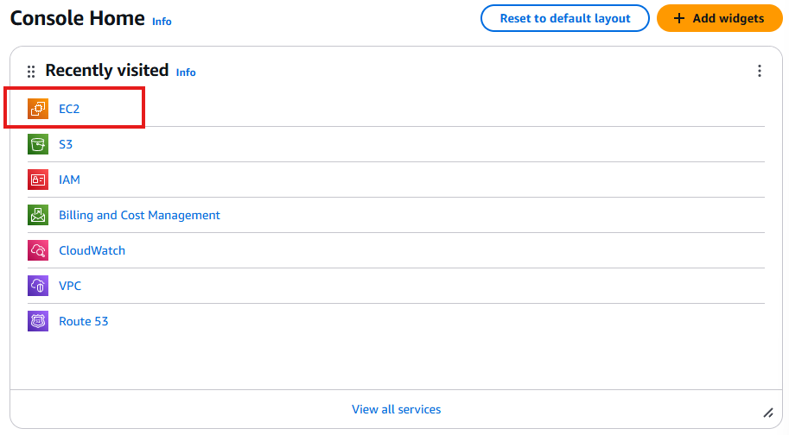

Go on resources dash board and Launch instance for EC2

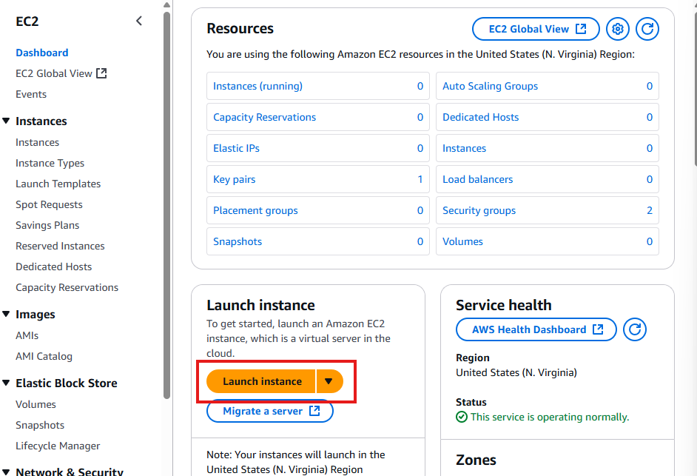

Name the instance and select amazon machine image as ‘Amazon linux 2 AMI (HVM)’

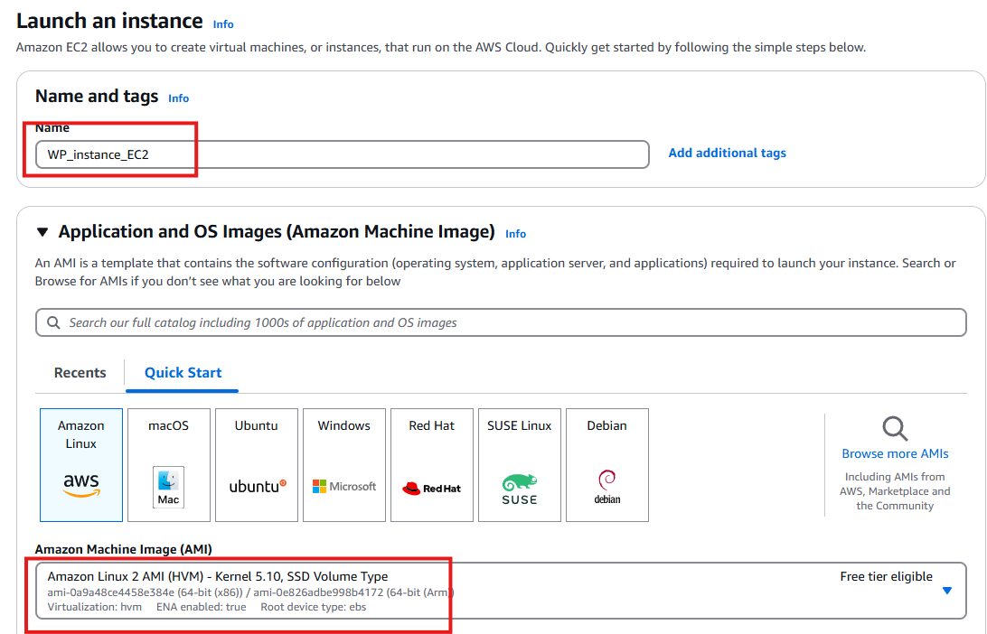

Keep the instance type as default and create a new key pair which can be used for secure ssh login

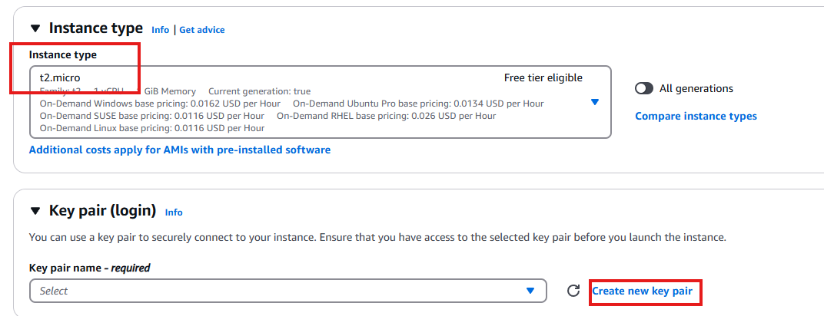

Create the key pair download it and save it.

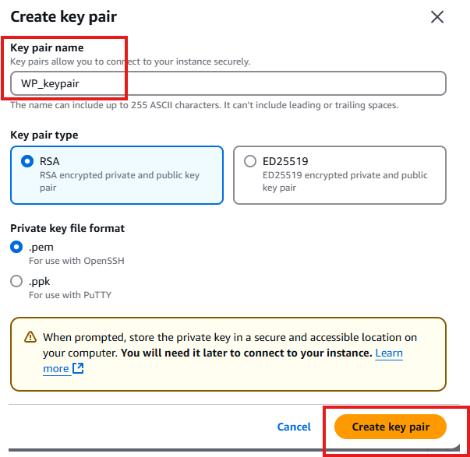

Since we are hosting Wordpress instance allow SSH,HTTP and HTTPS traffic from all over internet and click on the edit button and give a new name to the security group and description, inorder to distinguish security groups as multiple security groups will be used to connect to each other in future.

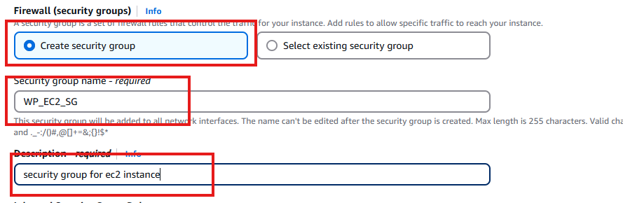

Rest all can be kept default and launch the instance.

After launching the instance wait for the instance to be up and running and the required checks to be completed and then click on connect button.

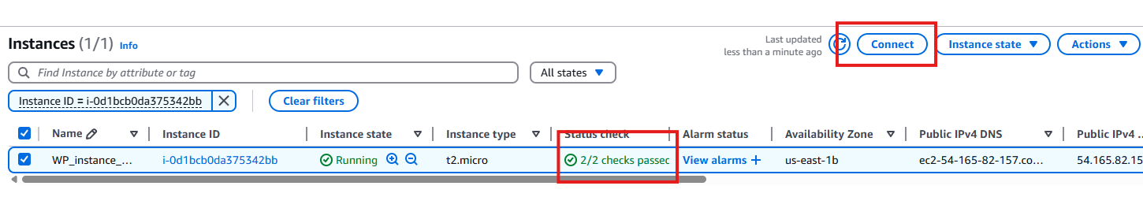

As of now lets connect with EC2 instance connect  
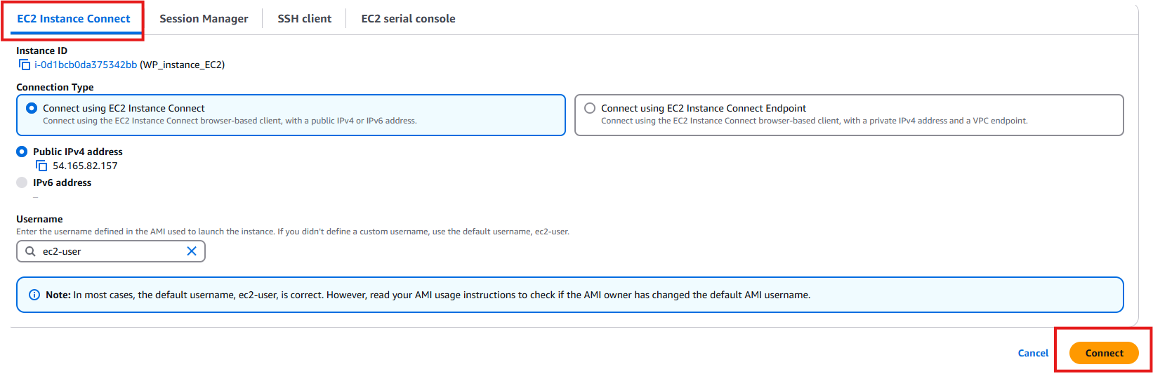

A new terminal will open and install the necessary installation for wordpress to be hosted on EC2 instance.  
  
Commands:  
>sudo yum update -y  
>sudo yum install -y httpd  
>sudo service httpd start  
>sudo systemctl is-enabled httpd  
>sudo systemctl enable httpd  
>sudo amazon-linux-extras install mariadb10.5 -y  
>sudo systemctl start mariadb  
>sudo amazon-linux-extras install php8.2 -y  
>wget <https://wordpress.org/latest.tar.gz>  
>tar -xzf latest.tar.gz

By the above commands we will install the necessary requirements to start the wordpress on our EC2 machine.  
  
We also need to setup database the Our EC2 instance , we will use Amazon RDS to store wordpress data into our database.

Go to AWS Management console and open RDS  
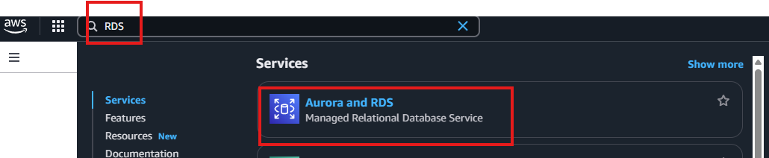

Click on create database:  
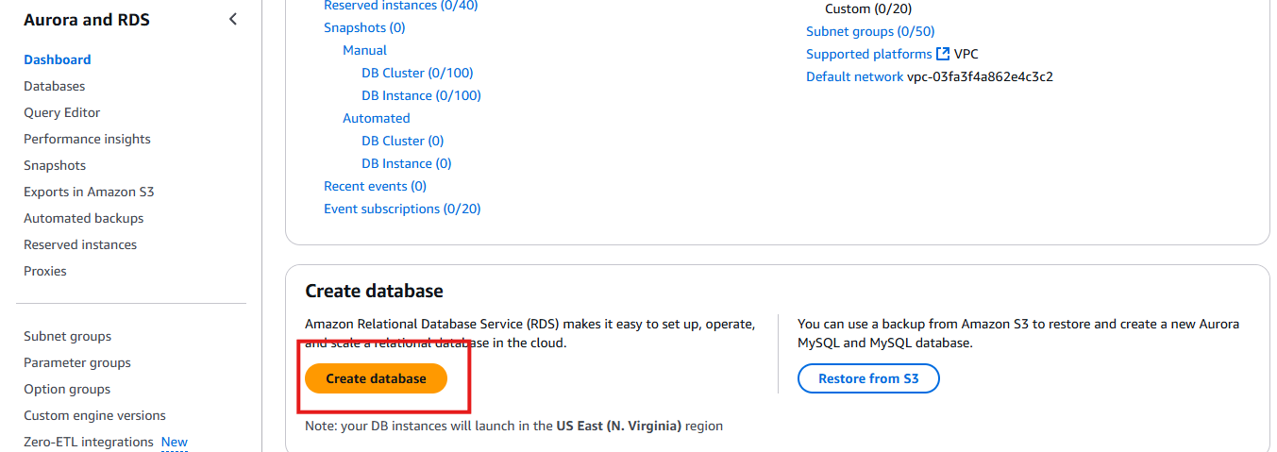

Below are settings for free tier Amazon RDS usage  
  
Select MYSQL under Engine Options  
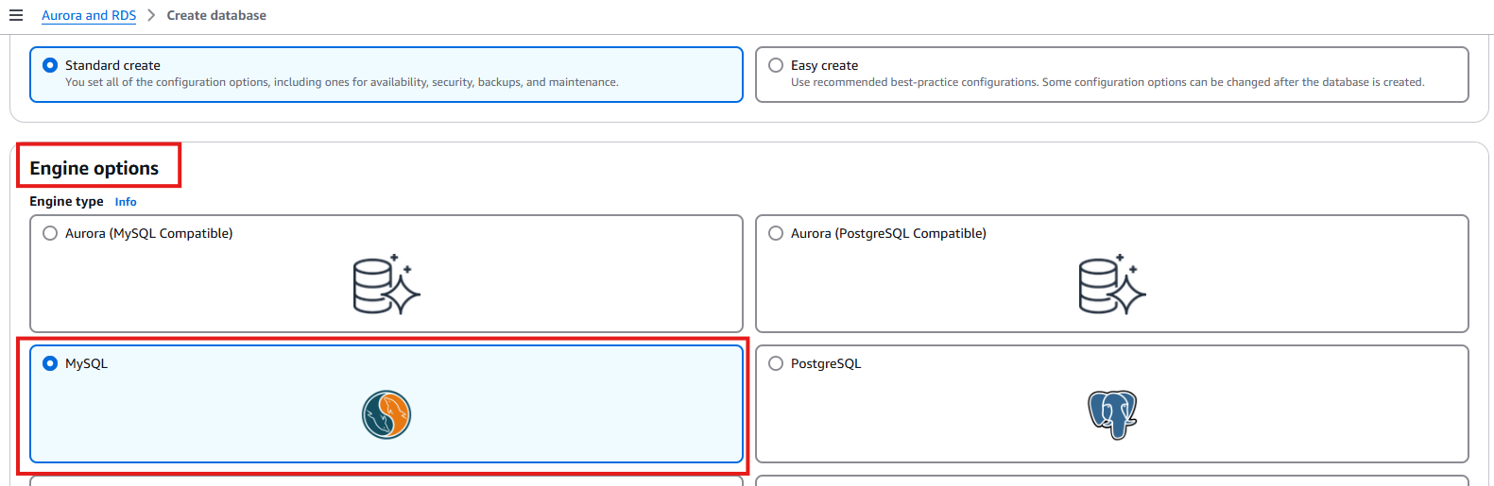

Select the Free tier under the Templates.

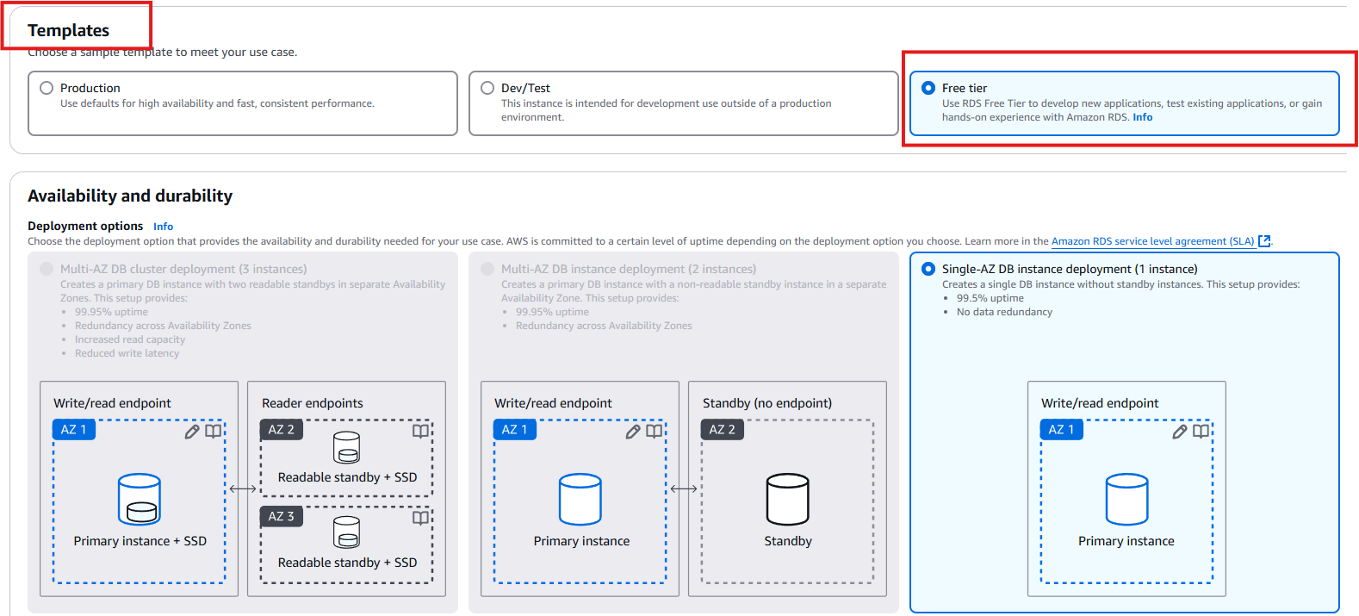

Give your Amazon RDS a name to identify.  
Select autogenerate password (this credentials can be viewed late in the database, to view click on view credentials)

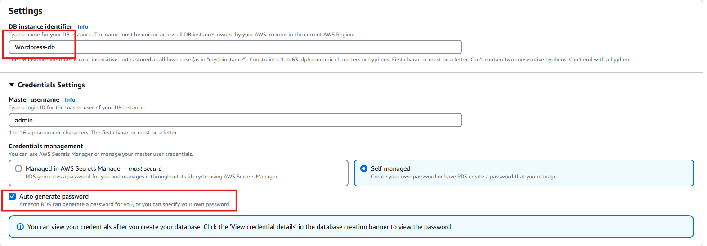

By default you will get the RDS instance configuration  
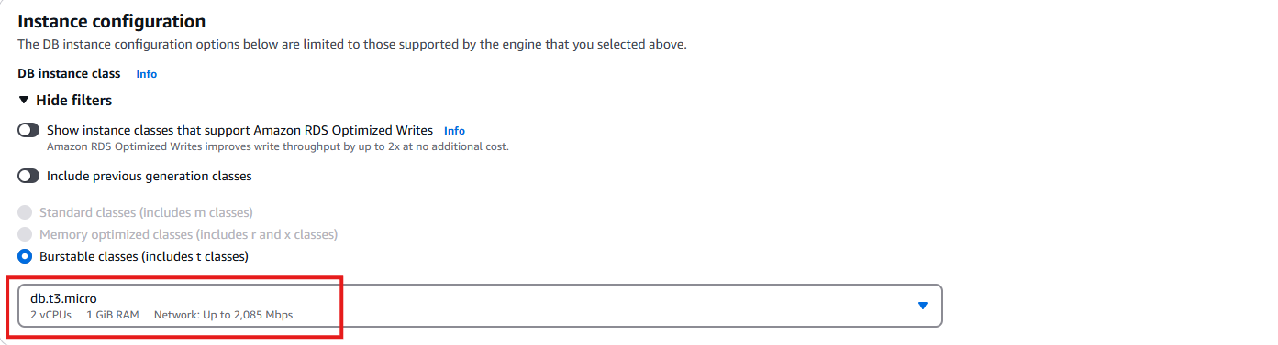

Keep the rest as default   
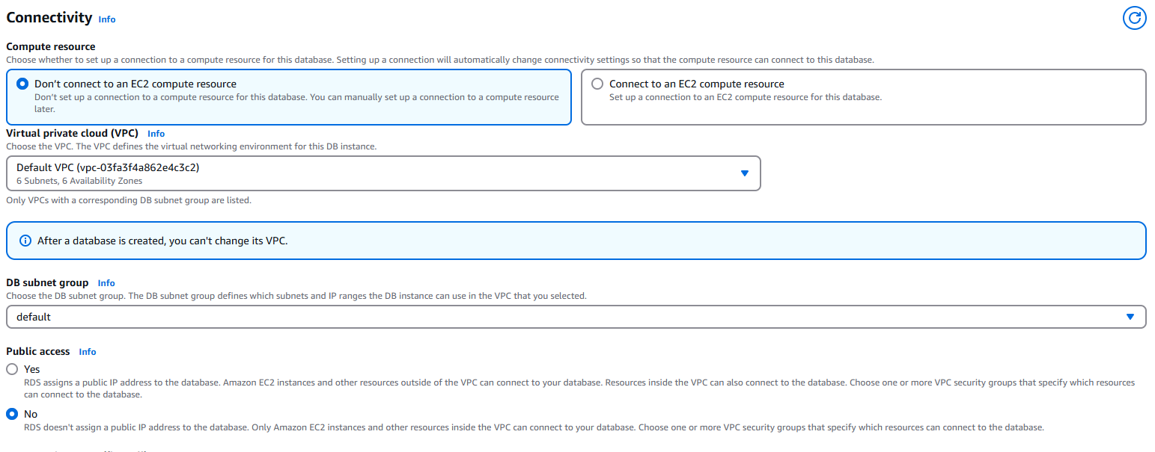

Now create a New Security group for Amazon RDS   
create a new security group  
name the security group  
keep the availability zone same as EC2 (you can view it from EC2 instance dashboard)

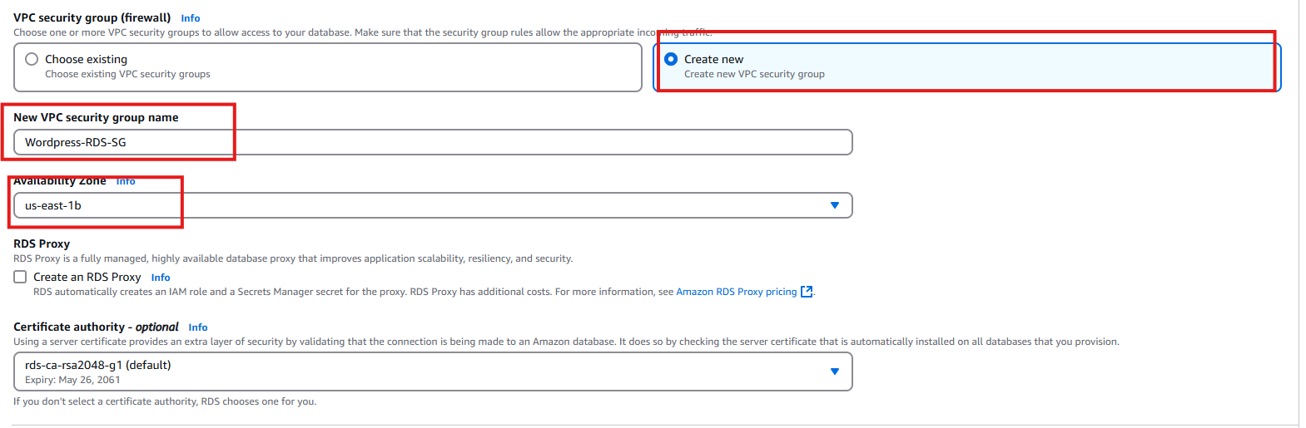

In Additional monitoring settings enable enhanced monitoring and logs , so this connected to CloudWatch for monitored on a granularity level.  
  
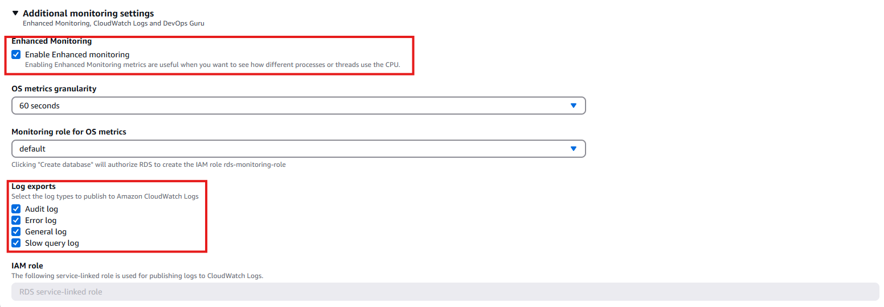

Go to Additional Configuration give your database a name and make the backup retention period to 30days, as a set for disaster recovery to protect the data in our database.  
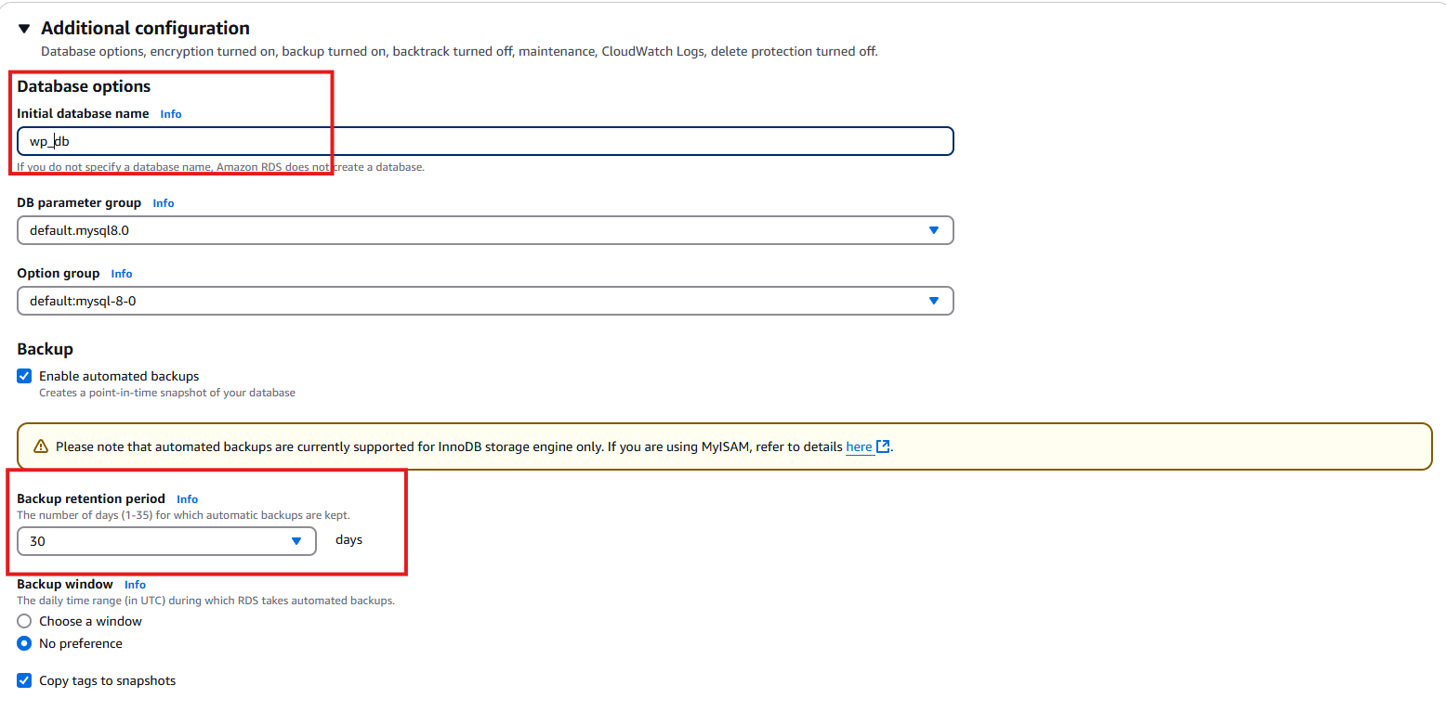

Click on create database



While the database creation is in progress wait for sometime, after databse creation is completed, you will get a pop up notification about the DB details and credentials.  
Note copy this credentials and keep safe as this will be used later to Connect EC2 and RDS.

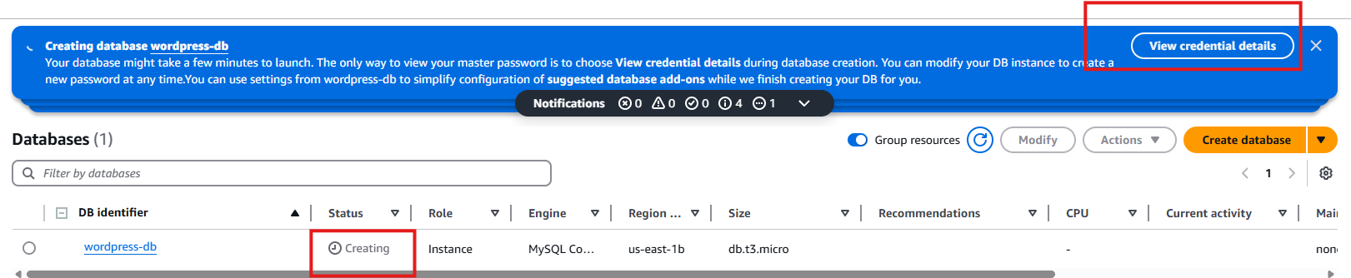

Example:  
Master username  
admin  
  
Master password  
13WpAl6xkIKOd3ao0H2J  
  
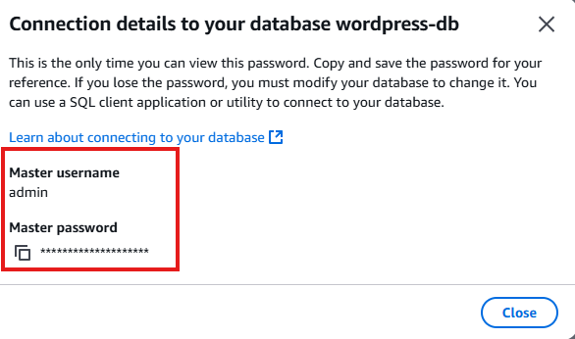

We are good to go !!!

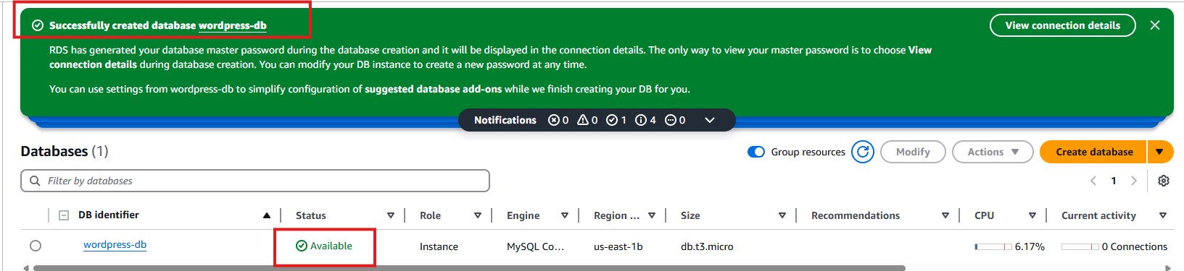

Connecting RDS and EC2 Instance

we will connect the RDS instance to our EC2 so that the data from EC2 can used in our RDS database to store the data.  
  
We need to add inbound rule to RDS Security group to connect to EC2 insatnce  
  
open the Database create in RDS.  
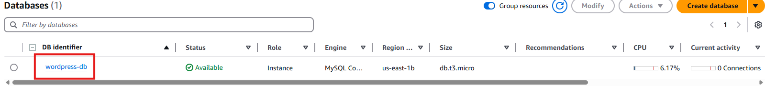

scroll down and got to security group rules and click on inbound type.  
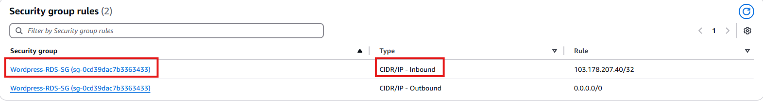

our security groups will open in a new tab remove the filters to view all the security groups we have created. (The highlighted groups are the one which will be used in this project.)  
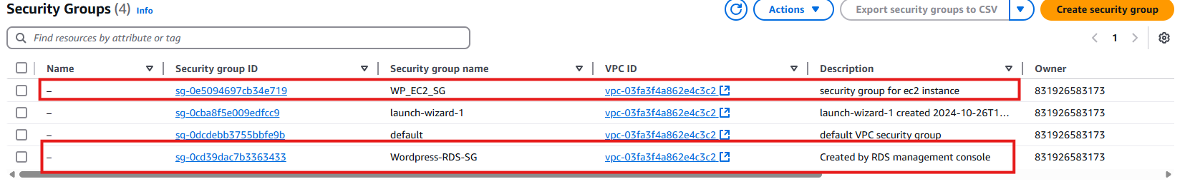

Now copy the EC2 Security group ID and attach it to the RDS as inbound rule(refer the above image ID) and select the RDS Security group. Go to inbound rules and click on edit inbound rules.

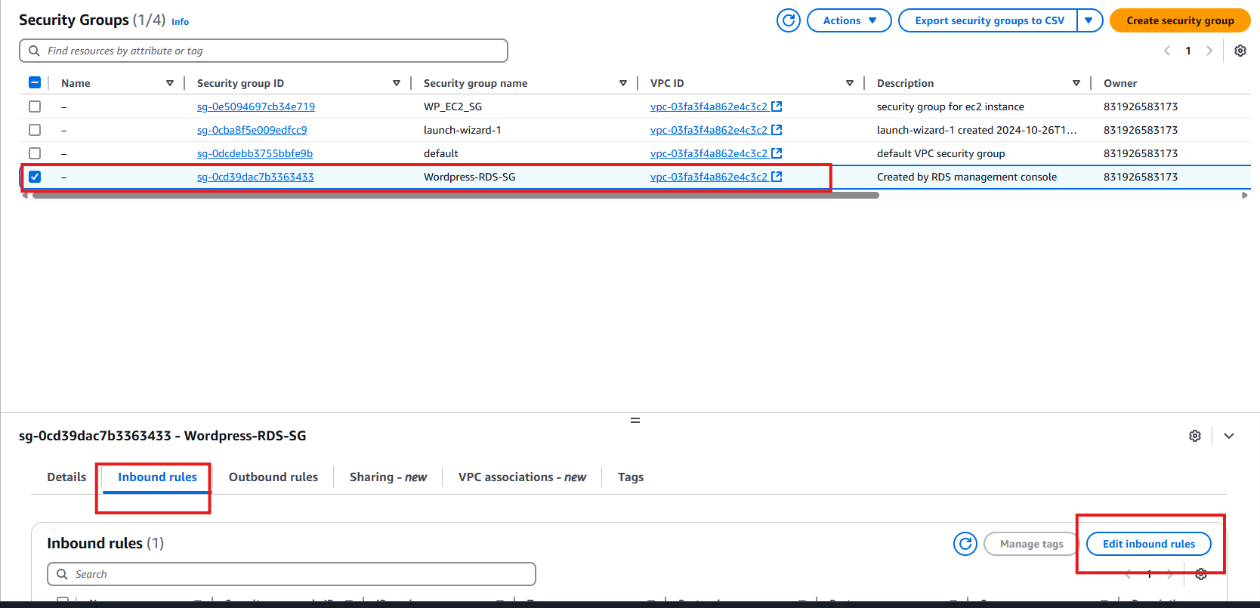

Paste the EC2 Security group ID.

Click on add rule and paste the security group. And save the rules.  
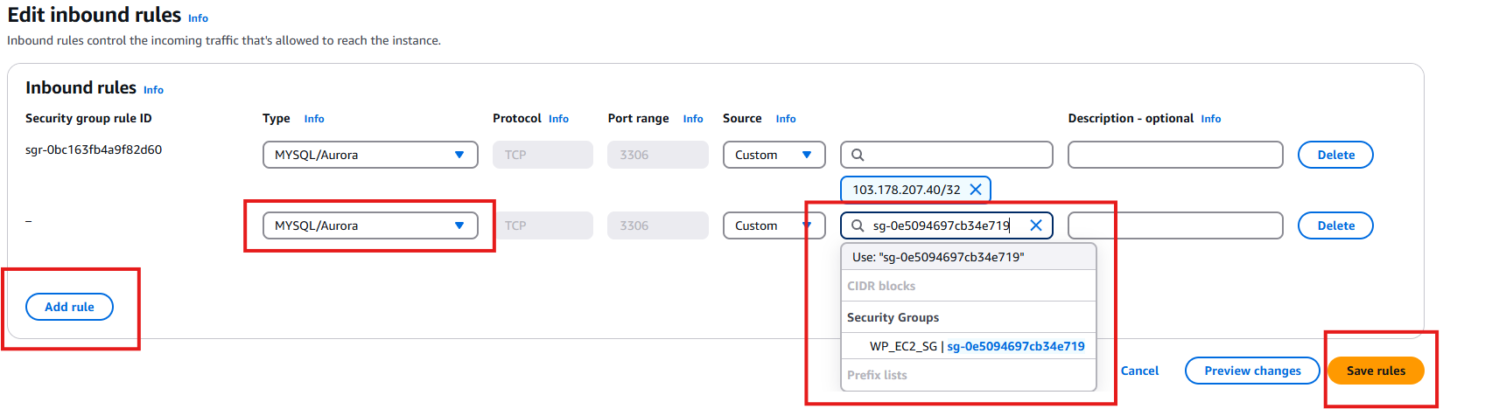

Lets check the if we can connect our EC2 instance to RDS

Open EC2 instance connect. And mention the below command.

You will get the host details in RDS dashboard and password we have saved it earlier  
Master username(RDS)  
admin

 Master password  
13WpAl6xkIKOd3ao0H2J  
  
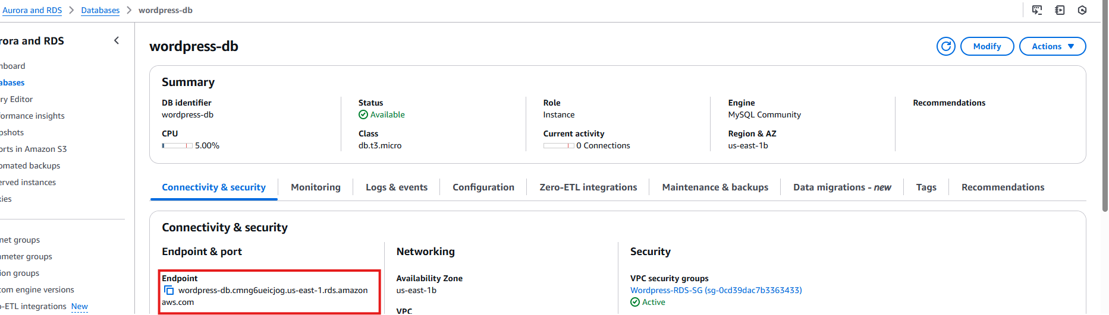

>mysql -h wordpress-db.cmng6ueicjog.us-east-1.rds.amazonaws.com -u admin -p

Cool !!! We are connected now.Connection Successful.  
  
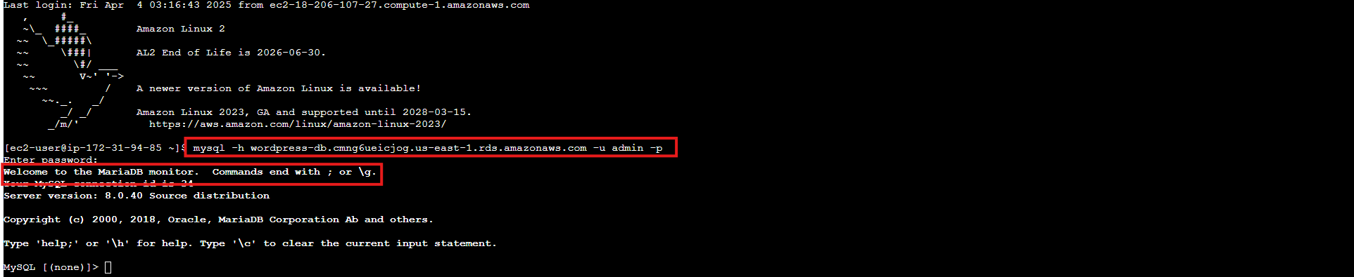

Till Now we have created EC2 Instance and installed wordpress required insatllations, set up RDS database, connect EC2 and RDS.  
  
Now lets go back to EC2 instance and configure files for Wordpress to be hosted.  
till now we have downloaded and installed php,maria db, wordpress zip file and unzipped it.

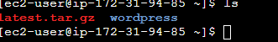

Add the below commands.  
>sudo cp -r wordpress/* /var/www/html/  
>sudo usermod -a -G apache ec2-user  
>exit  
  
we have copied the wordpress files to /var/www/html and gave the user excecution file commands.

Open the EC2 connect again.  
below we will change the file user permissions.  
>sudo chown -R ec2-user:apache /var/www  
>sudo chmod 2775 /var/www && find /var/www -type d -exec sudo chmod 2775 {} \;  
>find /var/www -type f -exec sudo chmod 0664 {} \;  
>cd /var/www/html  
>cp wp-config-sample.php wp-config.php  
>nano wp-config.php

Mention the details for connecting to Database(these details can viewed from RDS dashboard and the credential saved while creating the database.)  
  
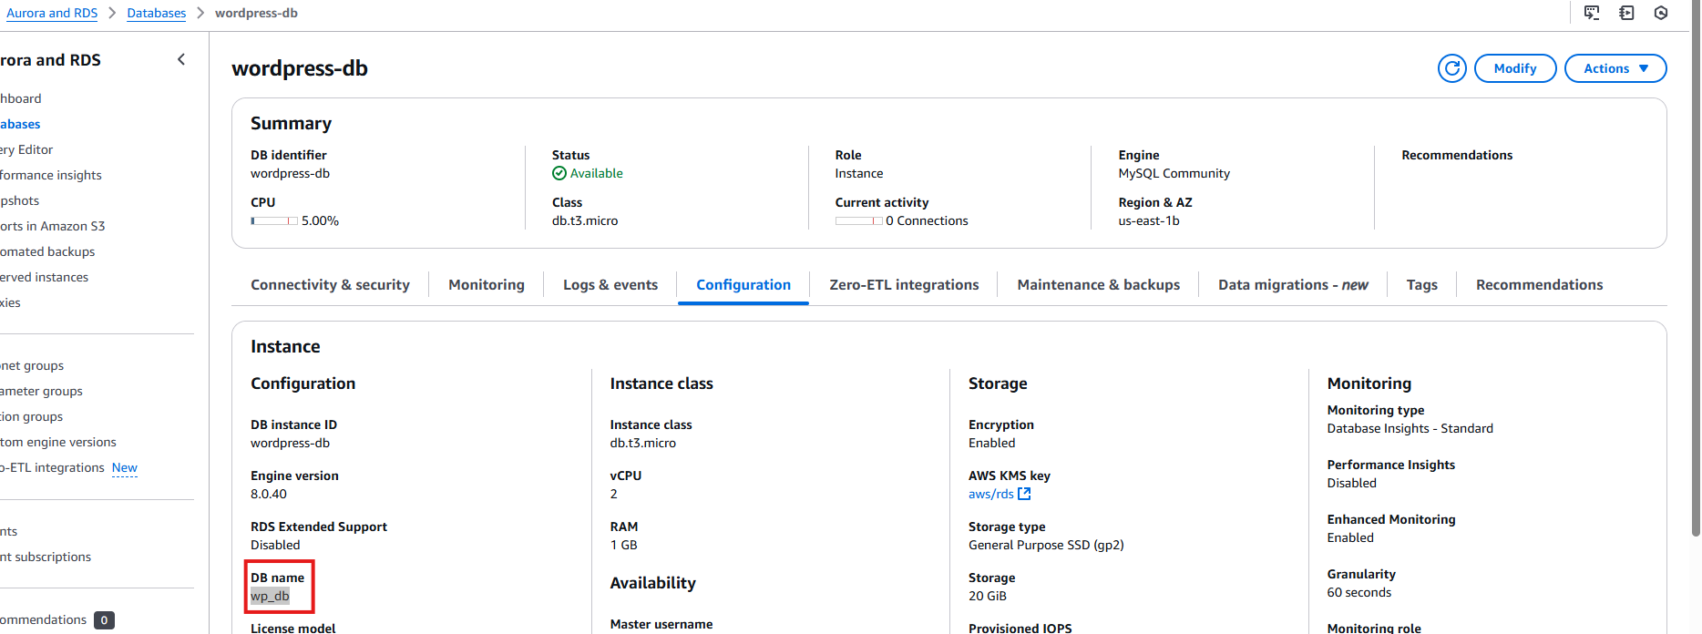

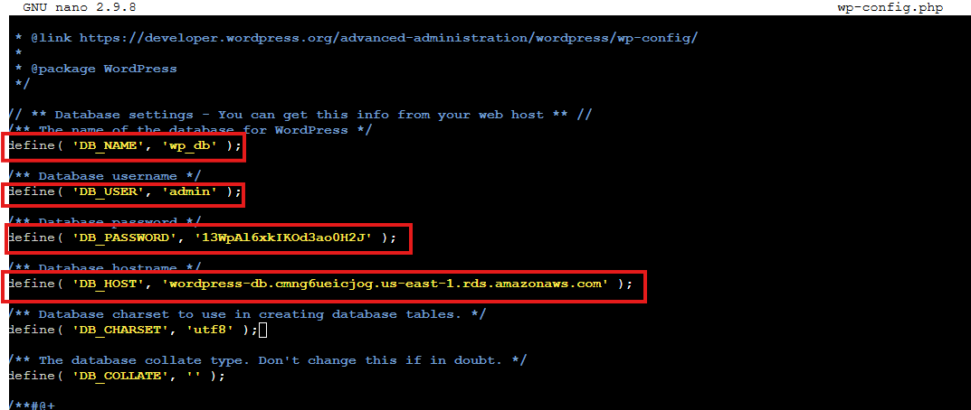

>cntrl+X, press Y  
>enter and save the file.  
  
now your config file is created.  
  
add wordpress to access permalink from our apache server.  
  
>sudo vim /etc/httpd/conf/httpd.conf  
  
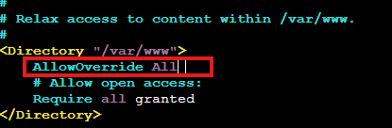

Save and exit then restart httpd.  
  
>sudo systemctl restart httpd  
  
  
Now we can open the Wordpress instance hosted on EC2 instance.  
got to EC2 instance Dashboard. Copy the public ip and open it in a new tab.

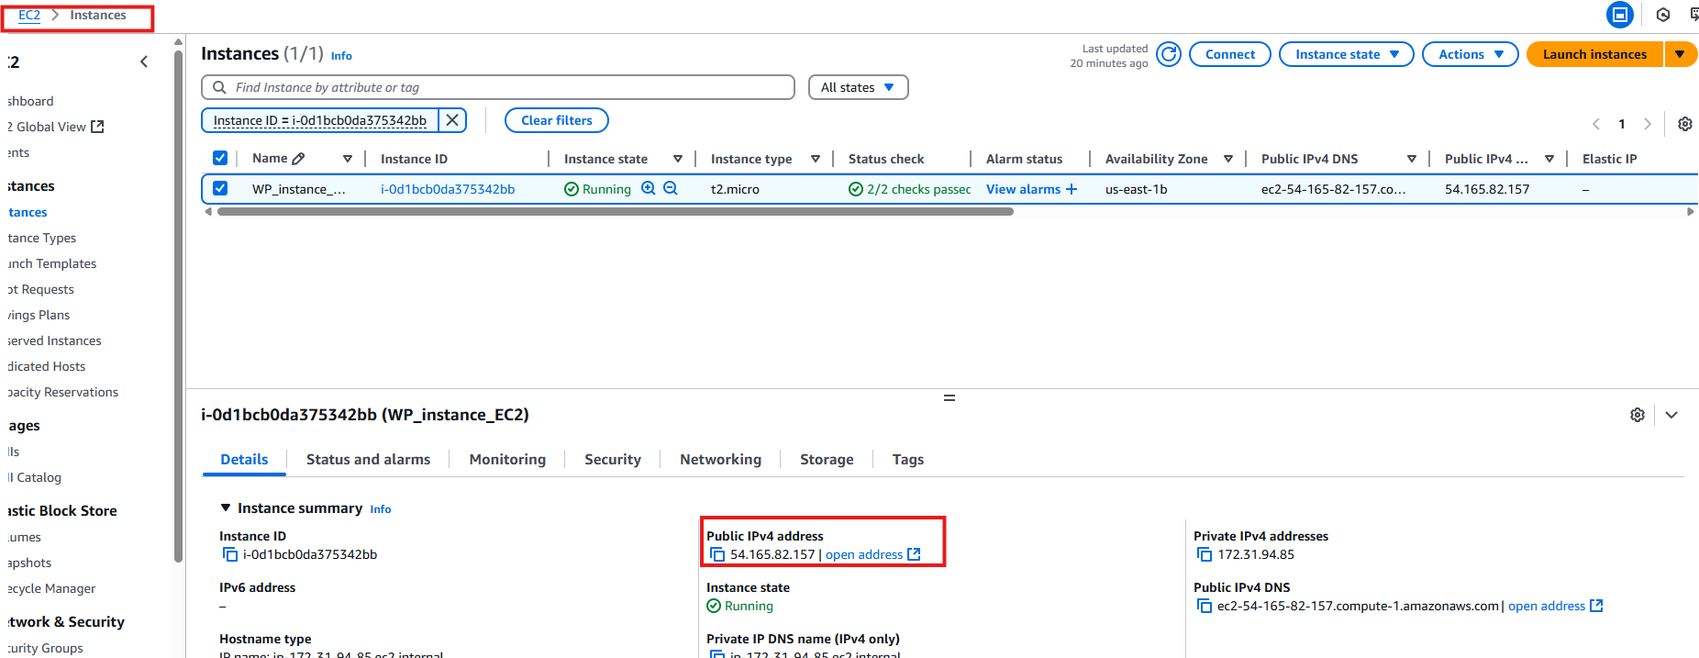

Possible error!!  
your Wordpress site might not open , fix it by removing the https to http request and open the wordpress instance.  
  


Cool !! We have our Wordpress opened, mention the details and click on install wordpress.  
  
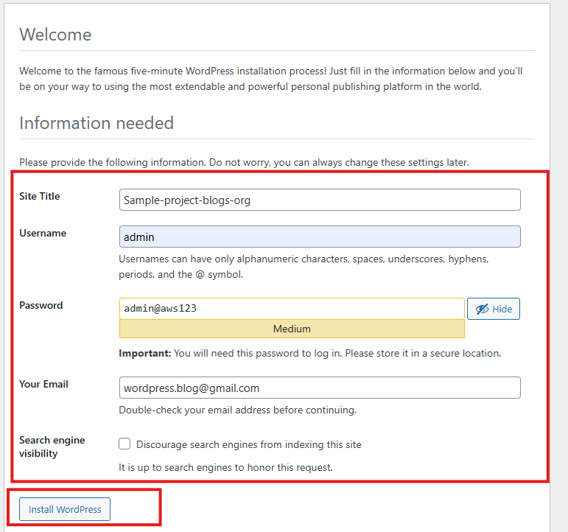  
Login and mention the details now you will be on Wordpress home page.  
  
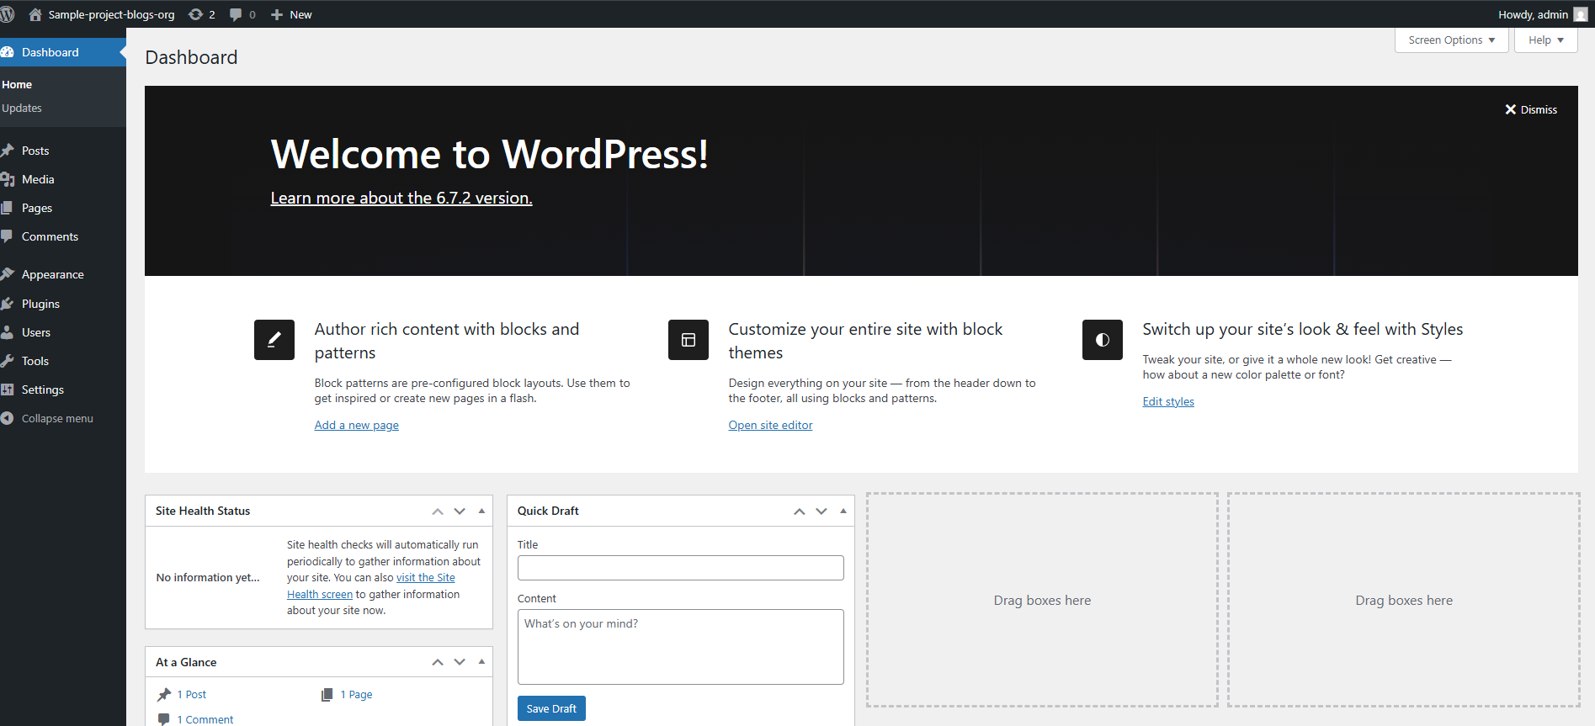

Since we are going to host blogs and maintain blog records, it is important to store the media as well which will be uploaded in the blog.

Since we will be creating the image of this machine later, below steps should be followed in order to bring up page properly and will be able to use the plugins from wordpress directly connecting to aws.  
  
open Running EC2 instance.  
>cd /var/www/html  
>nano wp-config.php  
  
add the below command in the file.  
  
>define('FS_METHOD', 'direct');  
  
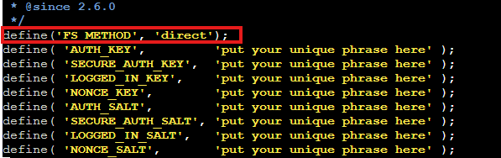

>cntrl+x, press Y

>enter and save the file

And run the below command do download xml extension for our wordpress to be compatible in running the plugins and restart the httpd service.  
  
>sudo yum install -y php-xml

>sudo systemctl restart php-fpm

>sudo systemctl restart httpd

>sudo systemctl status httpd

the status should be active and running.  
  
Now open the public ip where our Wordpress is running on the EC2 instance.  
go to the Wordpress dashboard  
  
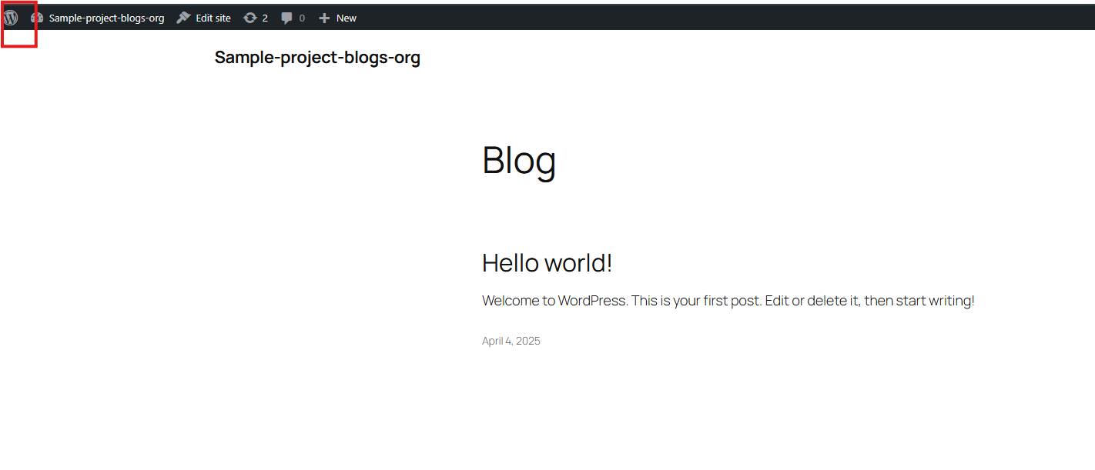

click on plugins->installed plugins  
  
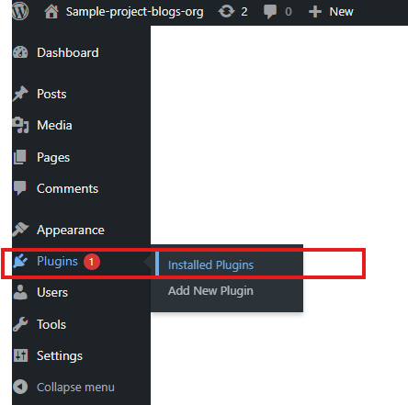  
search for WP Offload media S3 in search bar -> click on search wordpress plugin directory

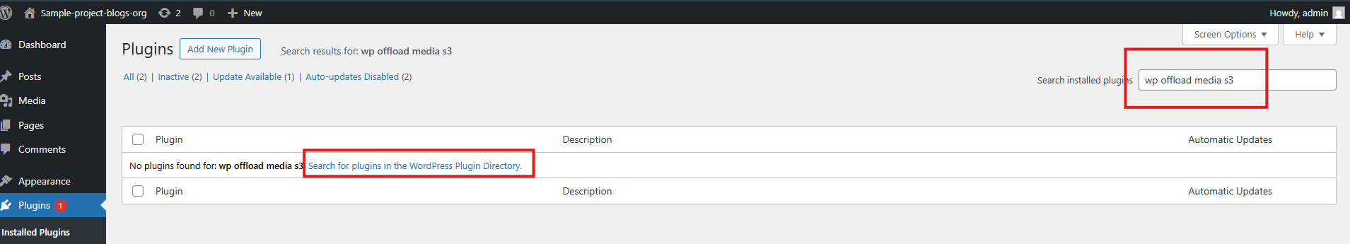

Click on install now.  
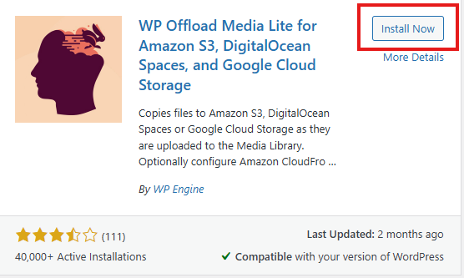

After the plugin is installed activate it and go to plugins in dashboard -> installed plugins -> WP Offload Media->and open the plugin.  
  
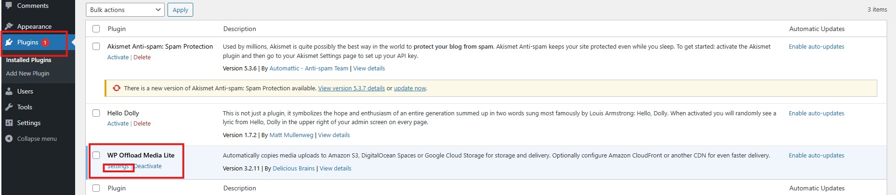

You will see provider , connection method and credentials.we need access key and secret key to connect to AWS S3 bicket and manage our media Like the below.

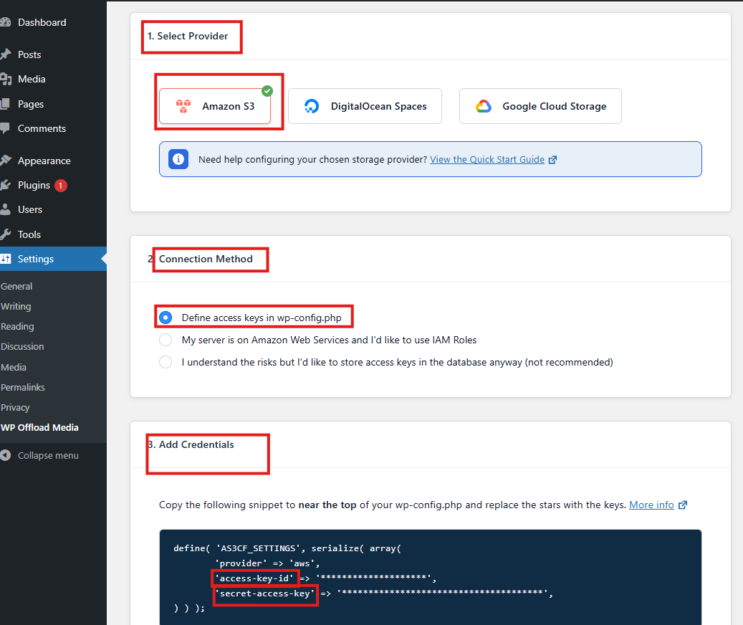

Since we have to manage media it is better to have a file manager to view and aceess the files, we can install the file manager plugin as well.  
  
go to plugins->installed plugins->search for file manager -> click on search wordpress plugin directory

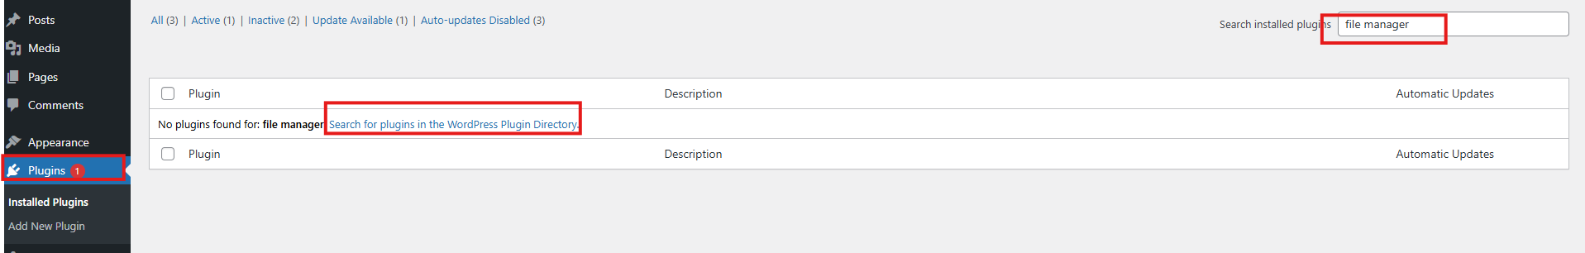

Click on install and activate

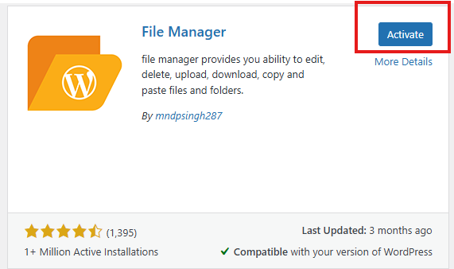

A nes section will be created in the wordpress dashboard , you can open the WP file manager from the dashboard.

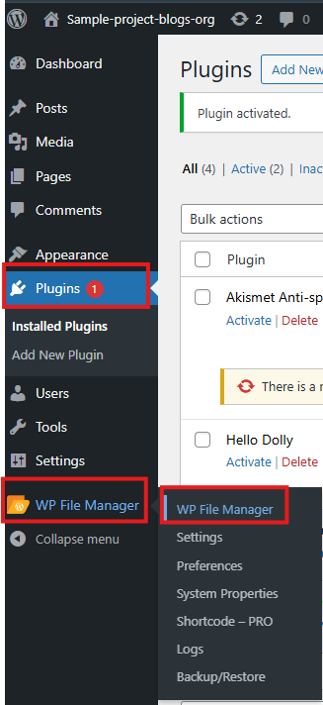

You can skip the verification.  
Now you can view all the file contents from Ec2 instance which is hosting the Wordpress.  
  
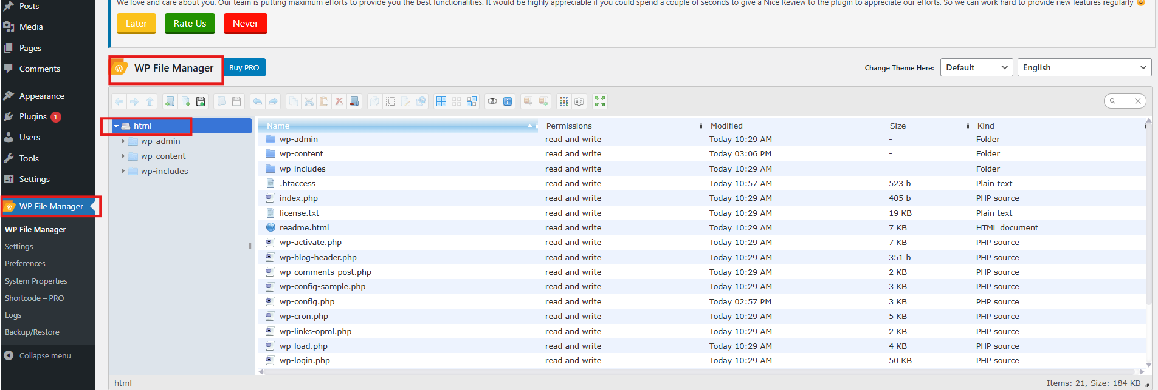

Right click on the wp-config.php-> code editer

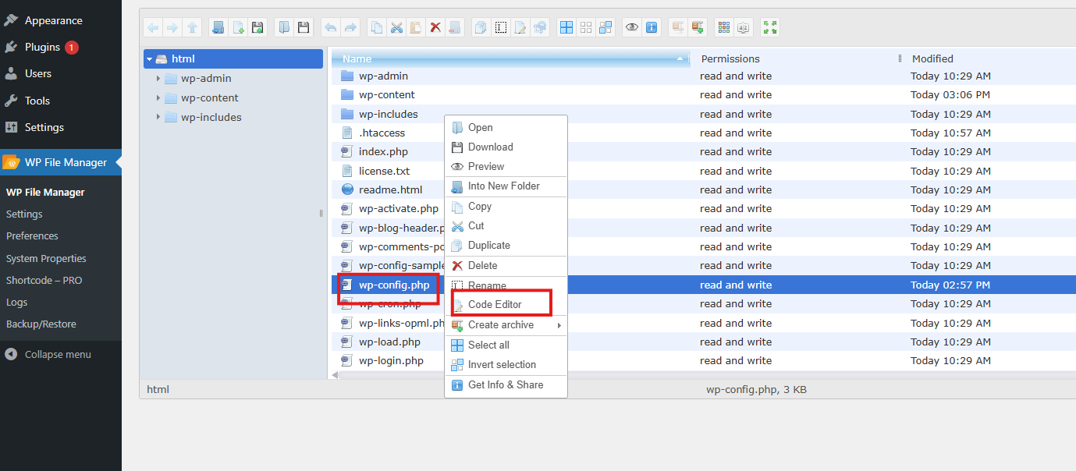

copy the code snippet form the WP Offload media settings.  
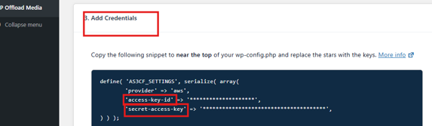

and paste it in the code editor

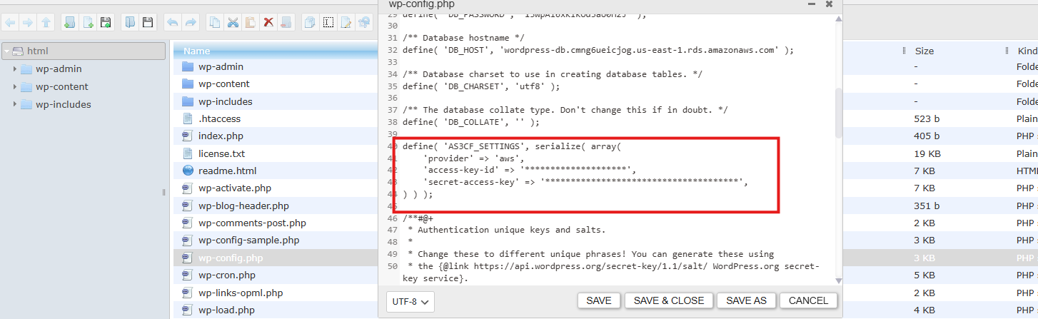

Now we will create the user and give the user full S3 access and programmatical access, and create an s3 bucket in AWS console.  
  
Open S3 in AWS console -> click on create bucket.  
  
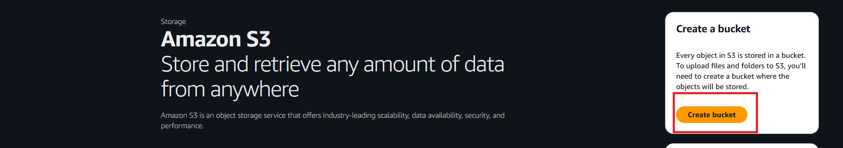

Name the bucket and use it for general purpose , you can keep the rest default.  
  
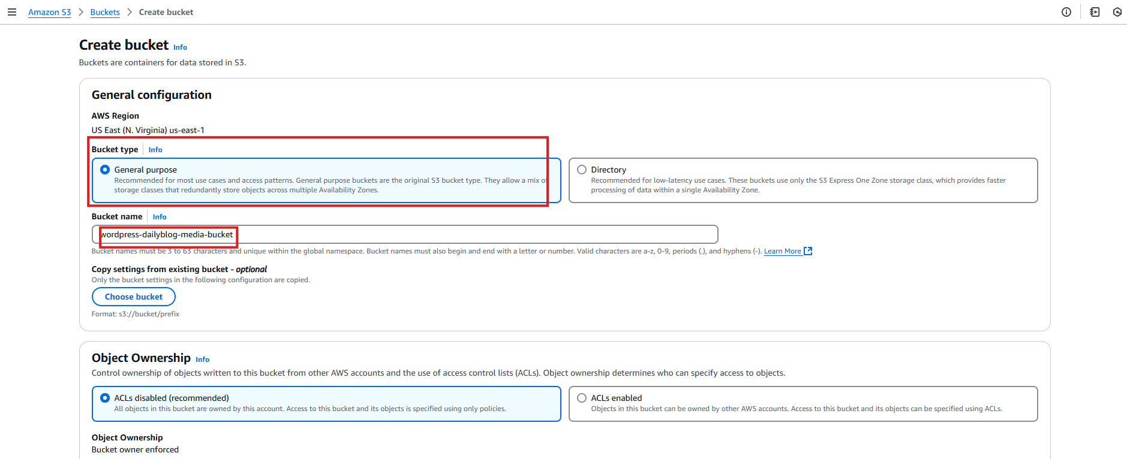

Review and create the bucket.

On the S3 dashboard open the bucket created and create a new folder.  
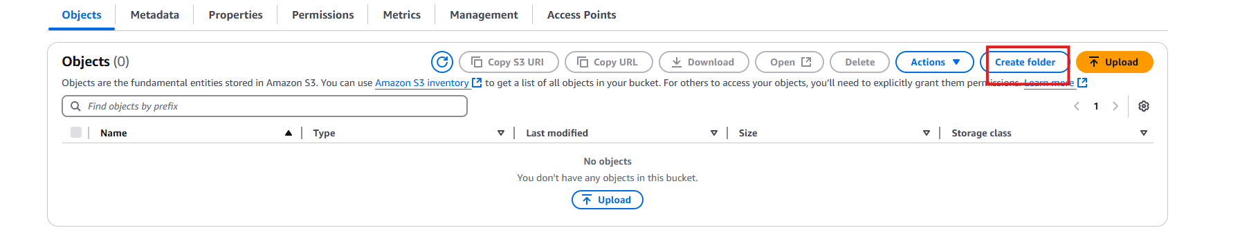

Name the folder as media, now we have created the folder where our media files will be store and will be able to retrive them.

Now open the IAM from AWS console   
on the dashboard click on users  
  
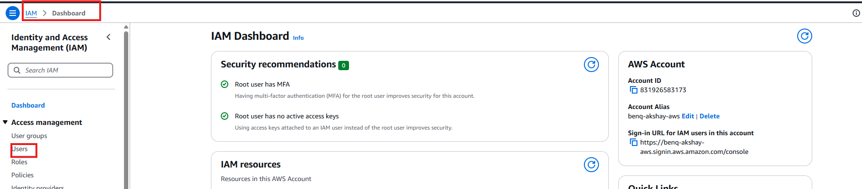

Create a new user

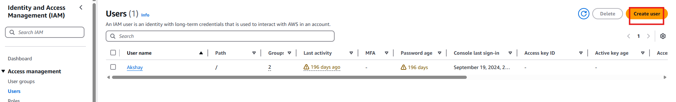

Give the name to the user and click on next.

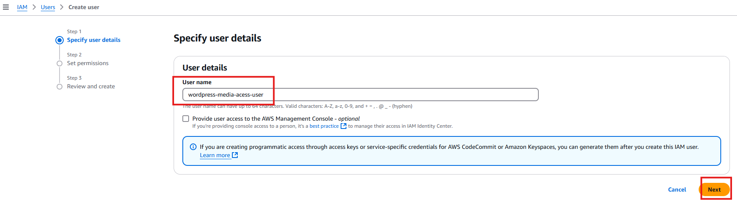

Click on attach polices directly and attach the Amazon S3 Full Access permission.  
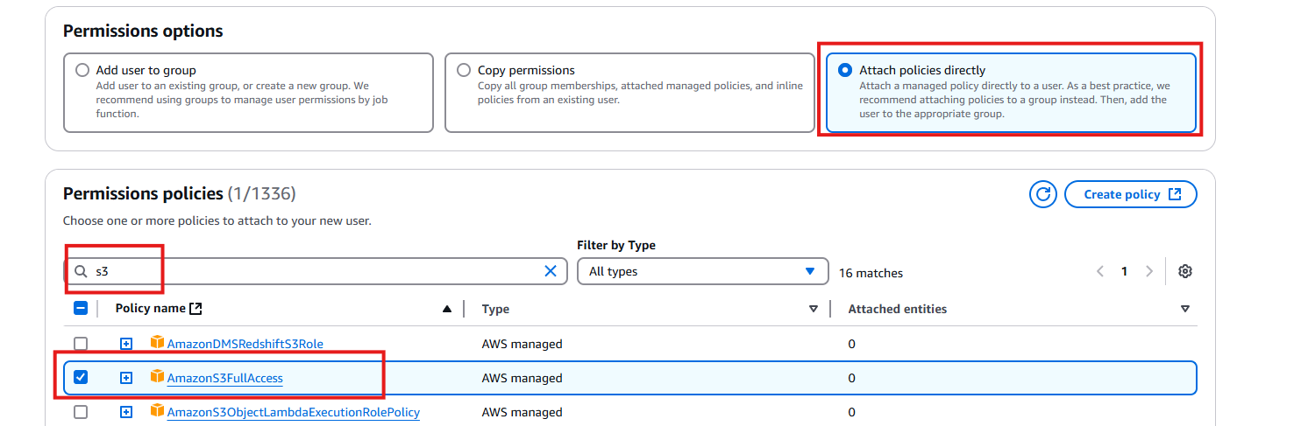

Now create user. We have created user with full Amazon S3 access for our wordpress media.  
  
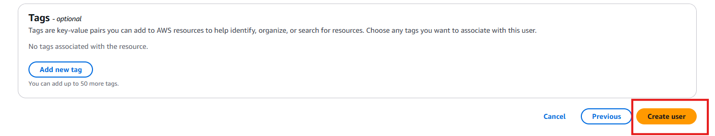

From the dashboard open the user to give programmatical access.  
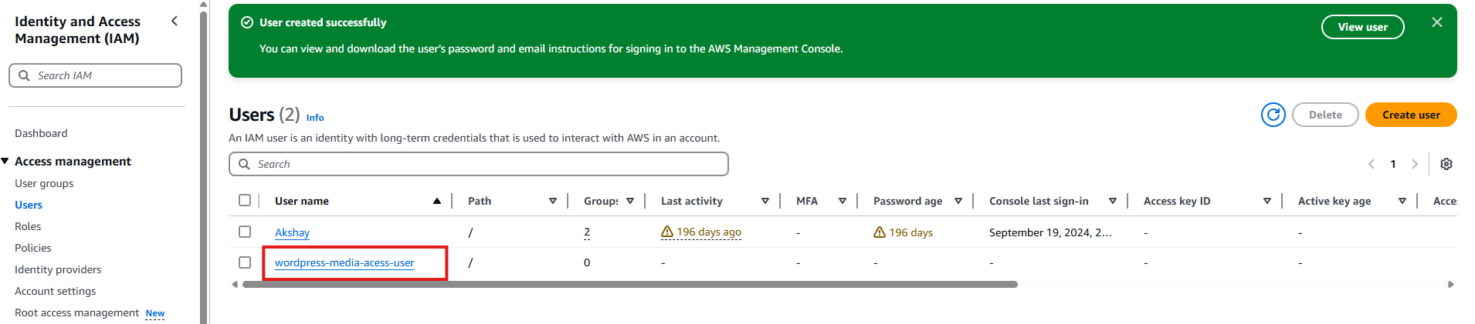

Create access key.

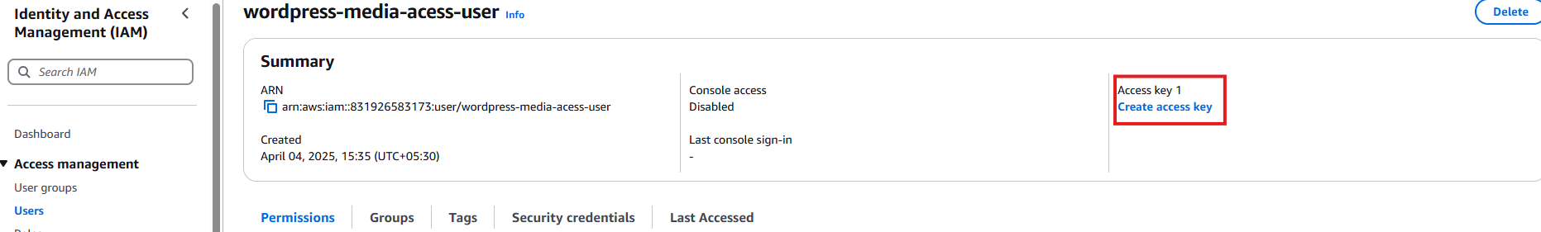

This is to create a programmatical access to 3rd party media and access the media from wordpress.

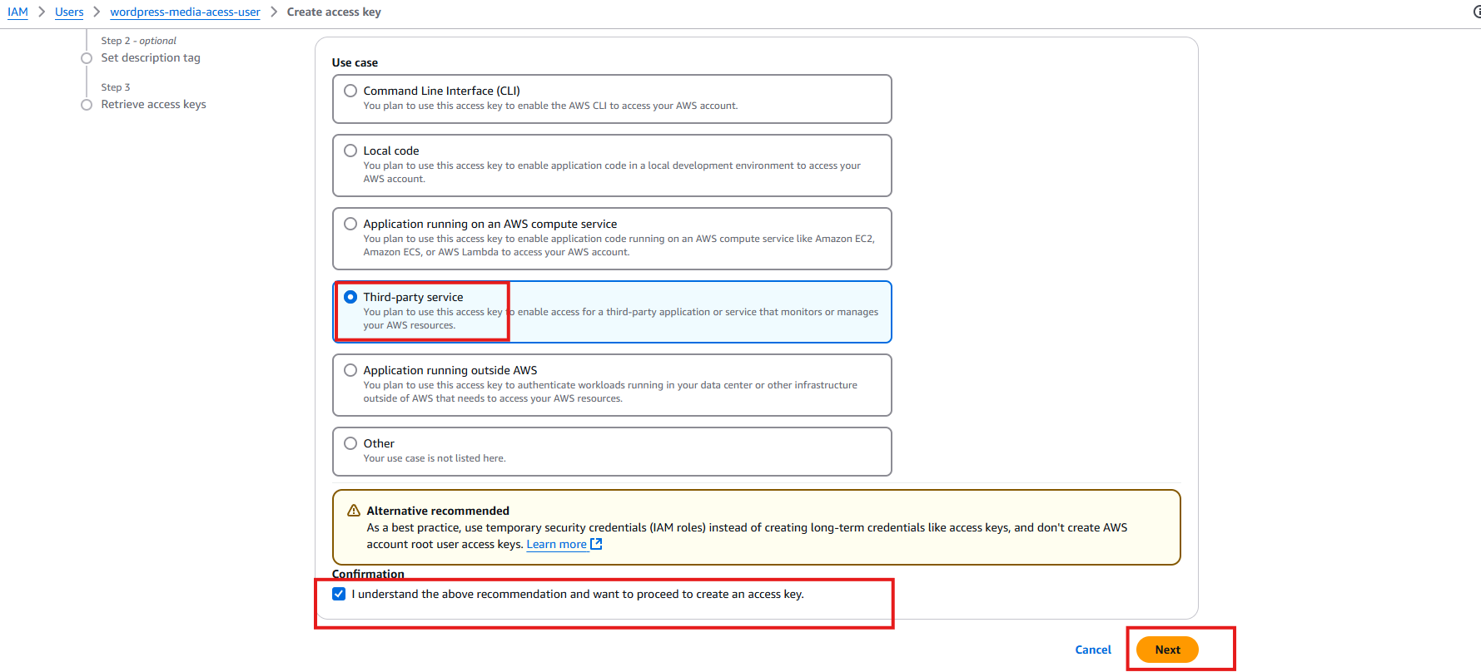

**Create Access key**

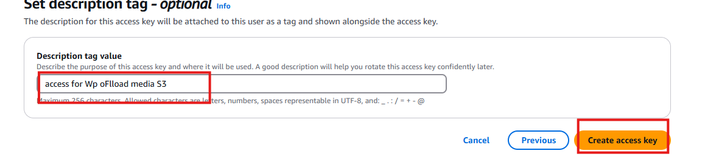

You will get Access keys and Secret access keys, copy them and save it or download the csv file.

(Note: the secret access key will be shown only once, recommended to copy the secret access key or download the csv file.)

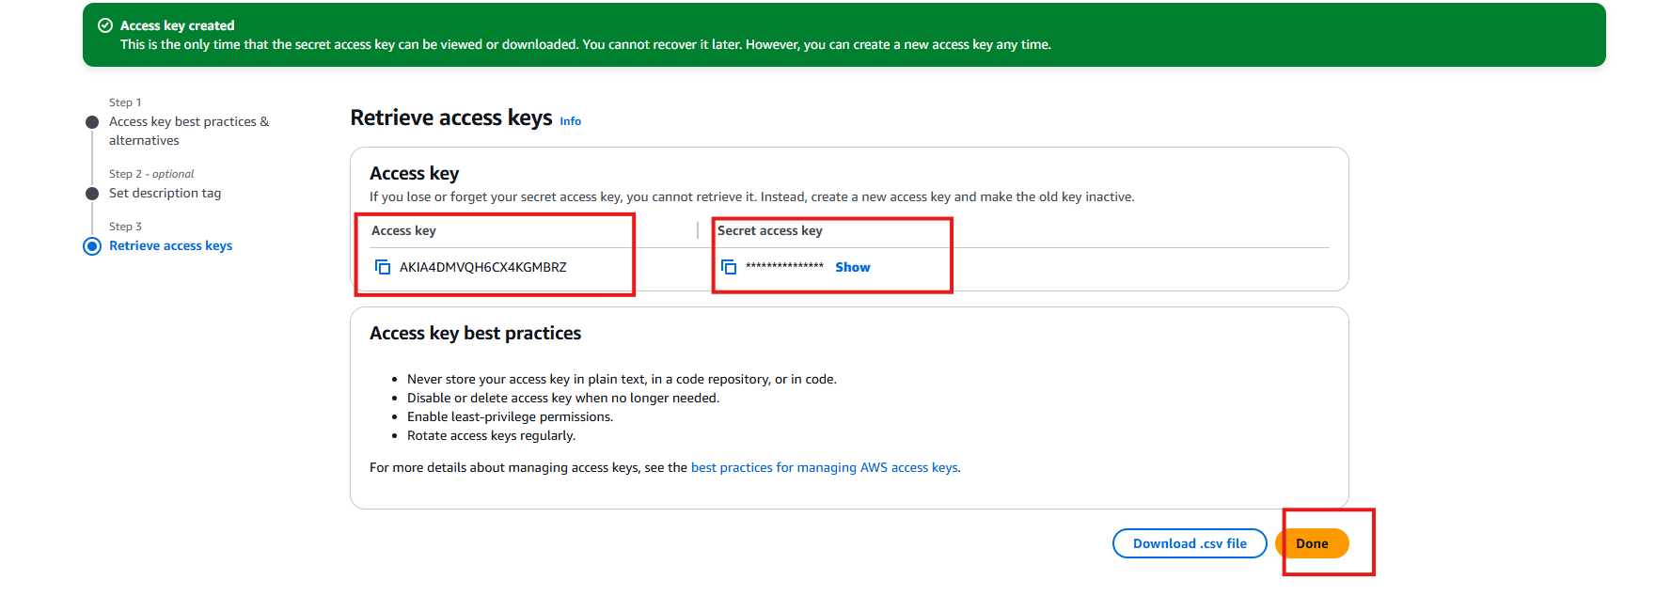

Now this keys will be used in the file manager code editor where the code snippet was copied.  
  
go to Wordpress file maganer-> open wp-config.php🡪 open code editor and mention the access keys and secret access keys.

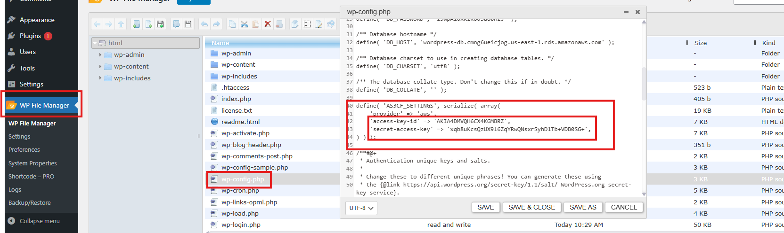

Save and close the file.

Now you can refresh the Wordpress page and open WP Offload media.  
 you will see an option to use existing bucket and mention the name of the bucket.  
copy the name of the bucket from AWS S3 dashboard. Or you can browse the existing bucket, it will detect and show you the existing bucket.  
  
This means we have connect the wordpress instance to our S3 bucket for media storage.

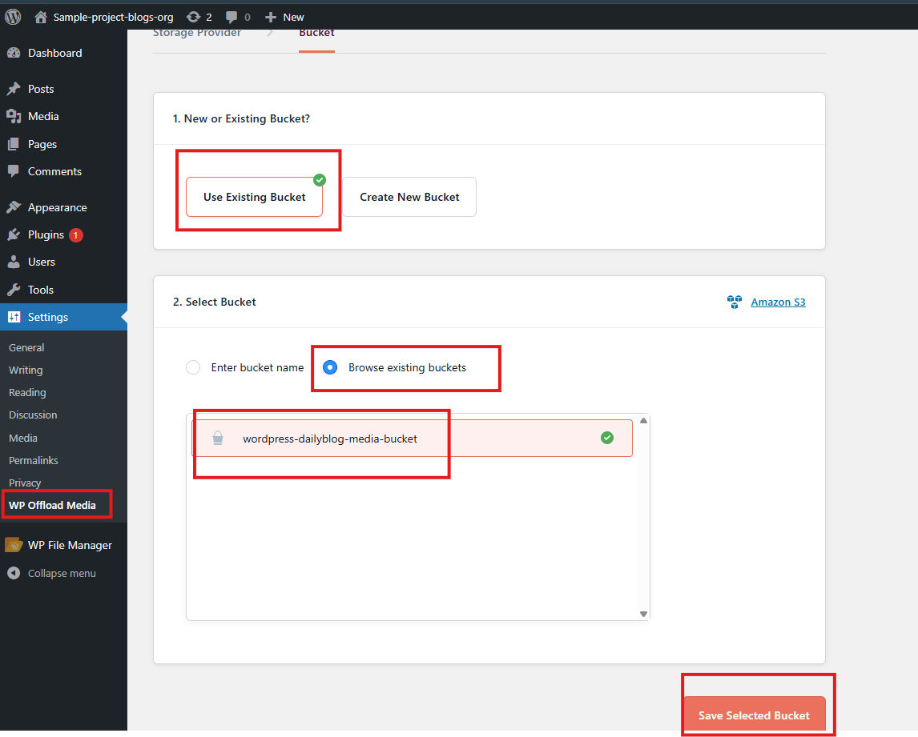

Save and select the bucket.

Disable Block public access and object ownership.  
  
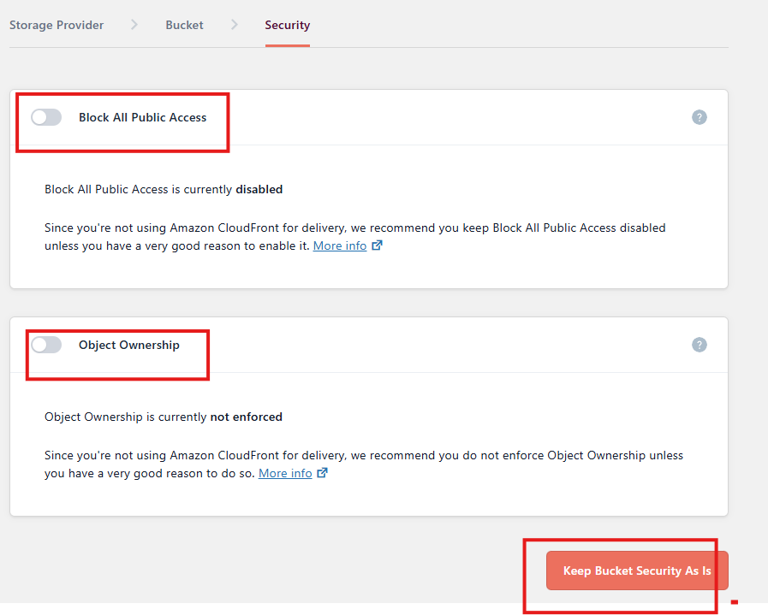

Click on keep as it bucket and proceed.  
accept the permission to mention details to the bucket, also enable the bucket versioning.  
  
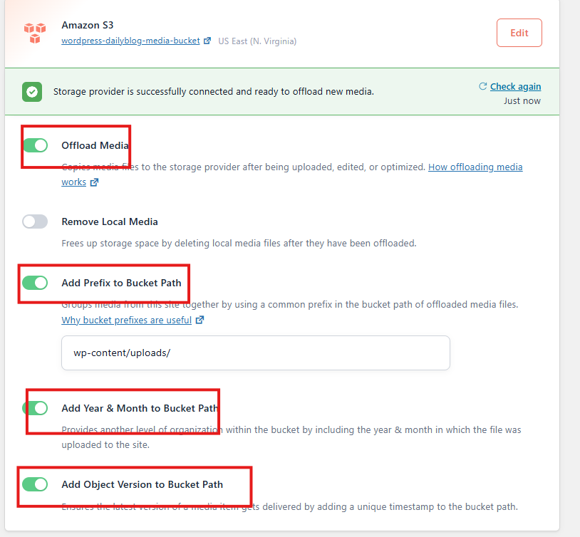

Click on save changes.

Lets try uploading few images to our wordpress media and create a blog.  
  
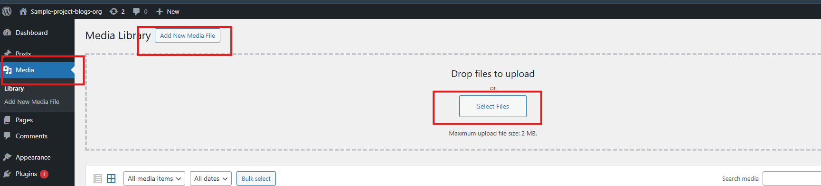

The file size should be less than 2MB.  
  
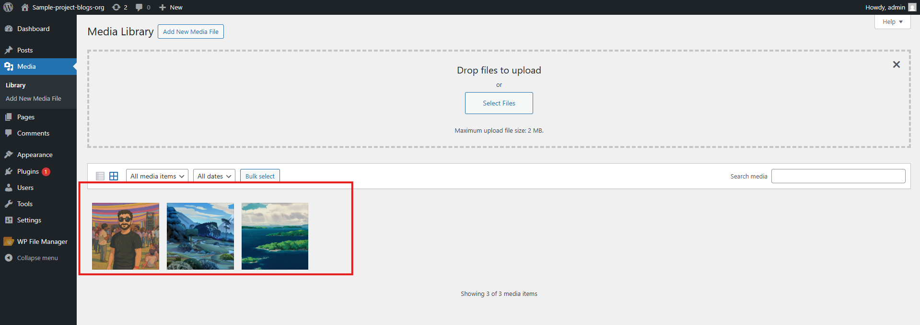

Sample images are uploaded. We can now create a sample blog.  
go to posts-> all posts-> add new post.  
  
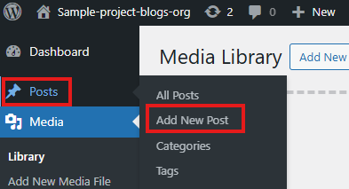

Create a sample post and publish it.  
  
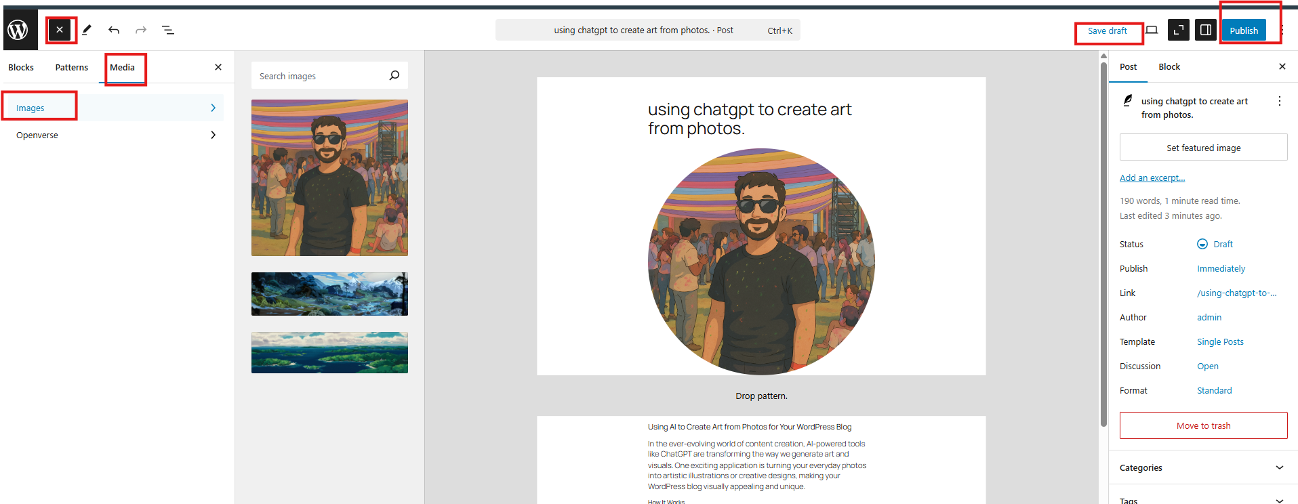

We have successfully created a blog and upload the media to S3 bukcet. You view the media in AWS S3 bucket and File manager from wordpress plugins as well.

This will ease the work of managing media and deleting them as required.

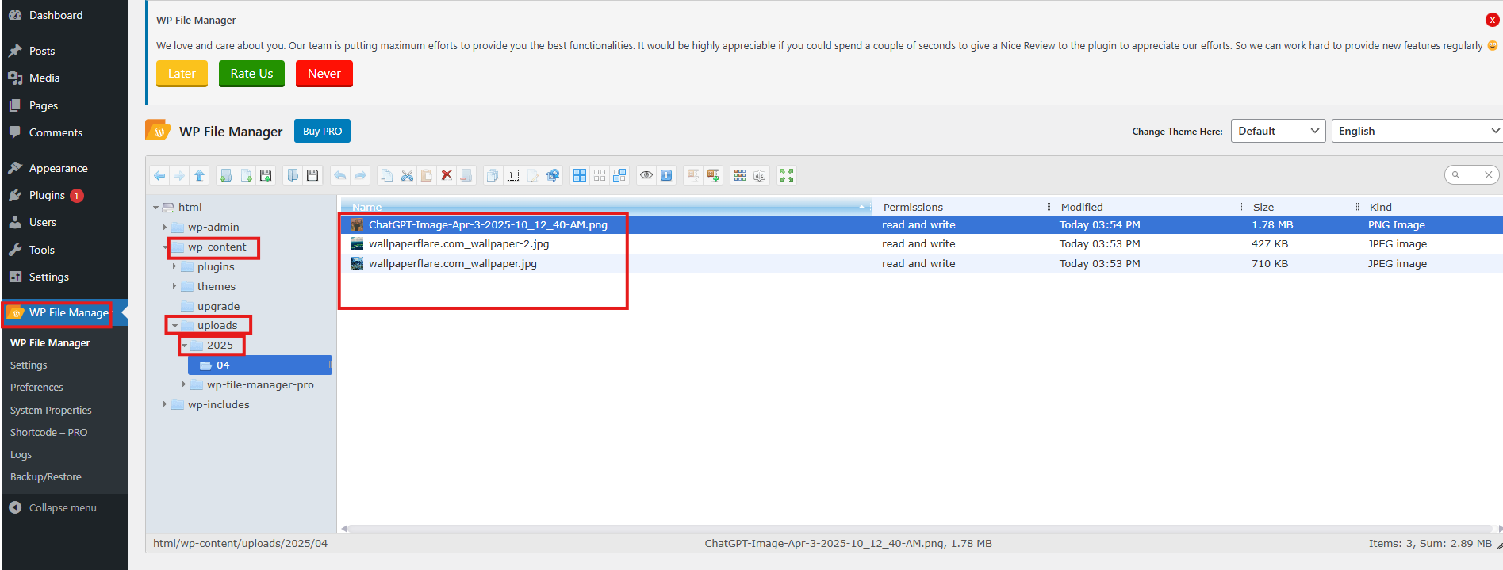

Also this can viewed from the S3 bucket.

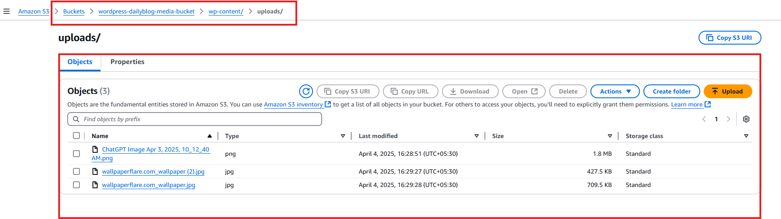

Setting Up autoscaling group for the EC2 instance to start at9:00 am and stop autoscaling at 6:00 am IST.

Create an AMI of the Wordpress instance.  
go to EC2 instance dashboard and create an image.

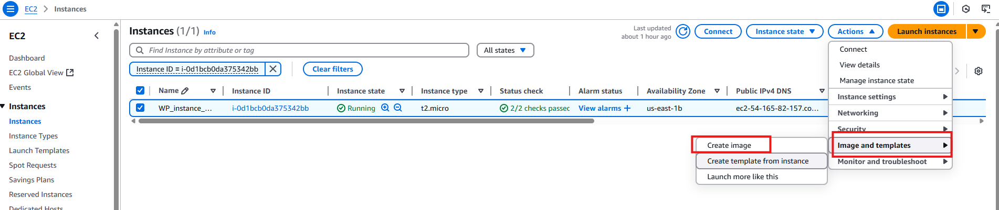  
  
enter the name and description for the image  
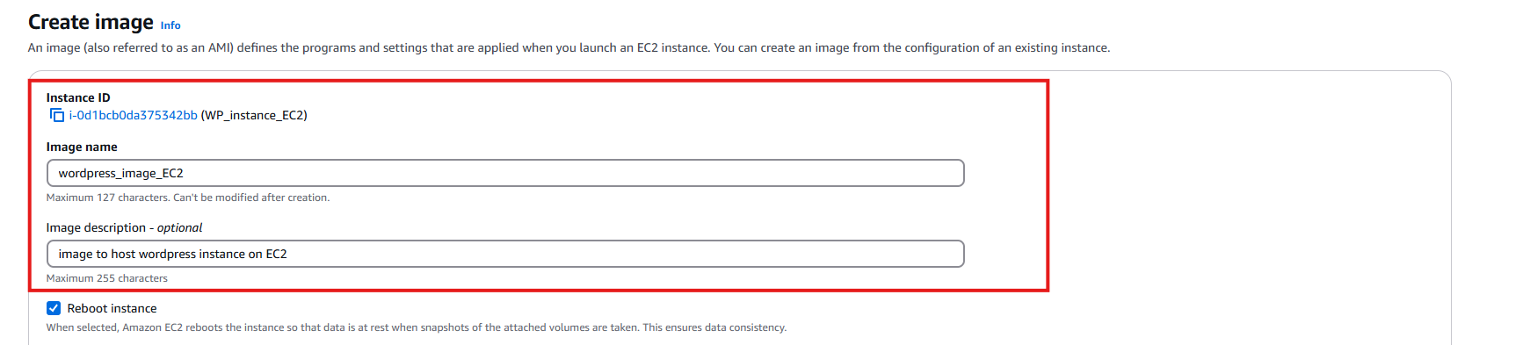

Go to AMI dashboard and wait for AMI changes from pending to available.

Go to AMI dashboard and wait for AMI changes from pending to available.  
  
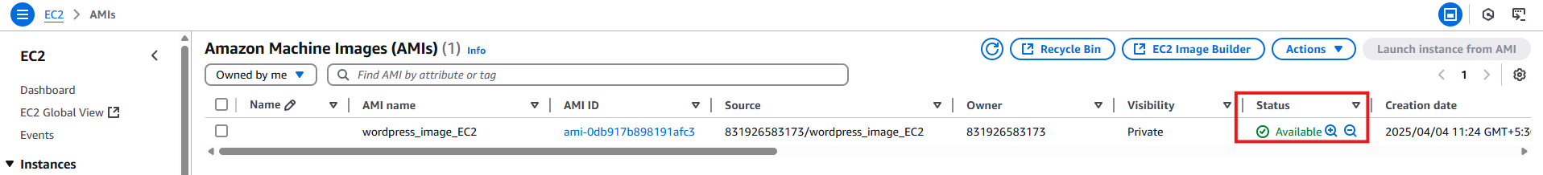

Go to Autoscaling groups

Create Autoscaling group.  
  
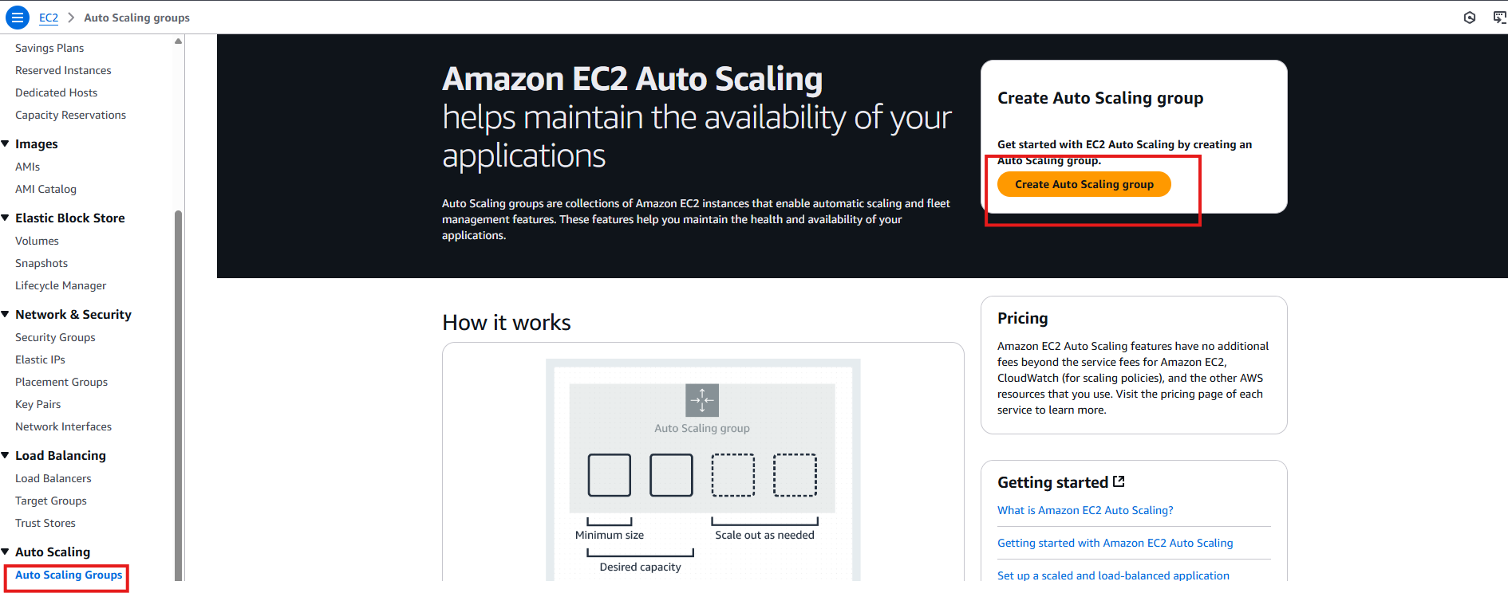

Name the autoscaling group and create the launch template.  
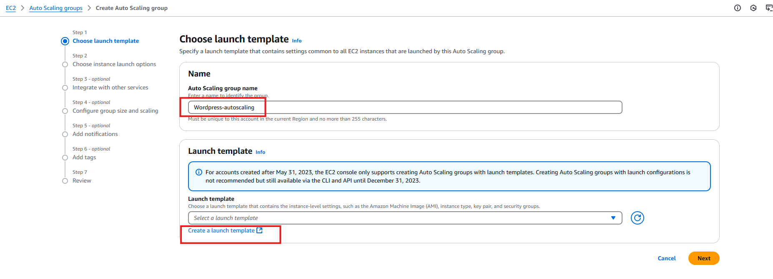

Add name to the template->select the AMI created🡪add the key pair🡪select the ec2 instance security group.  
  
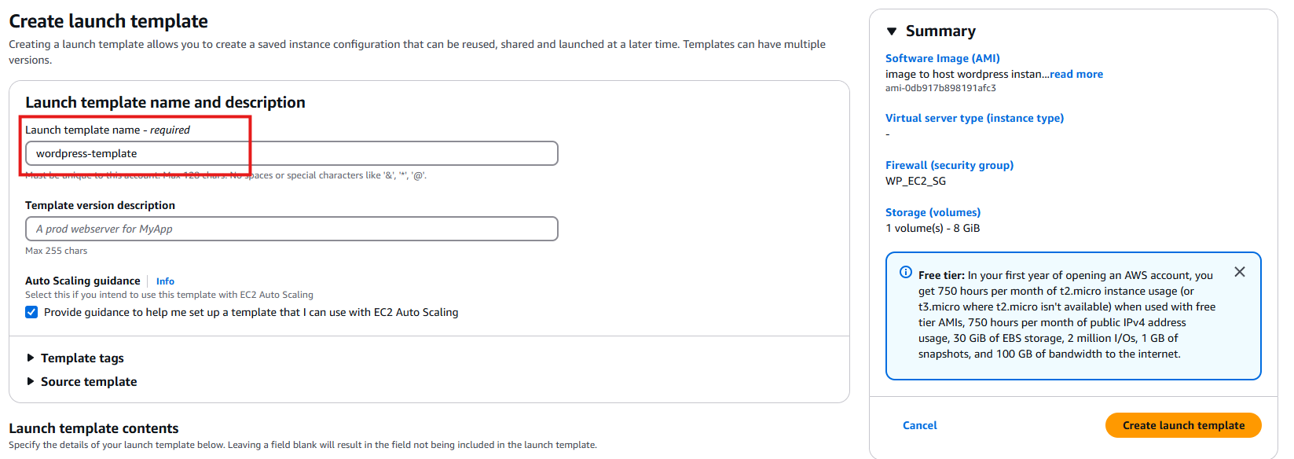

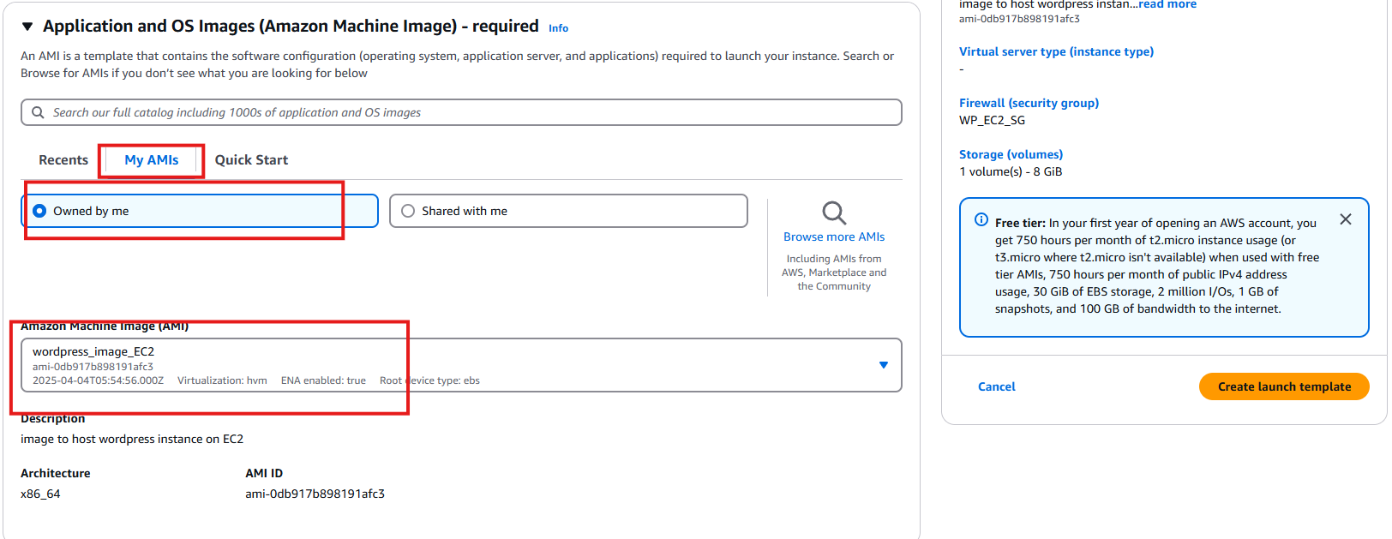

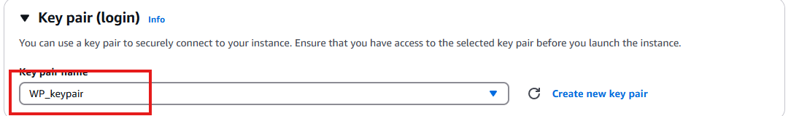

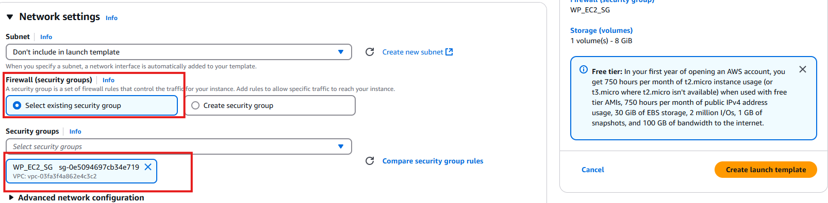

Create the launch template and select the template in the autoscaling group.  
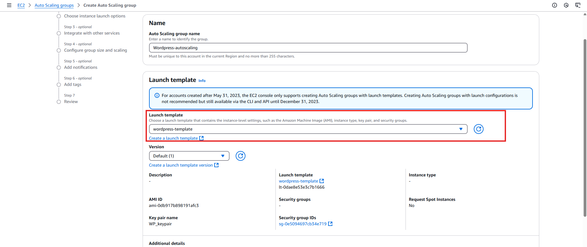

Select the maximum Cpu’s and Memory for the autoscaling group and default setting and proceed.

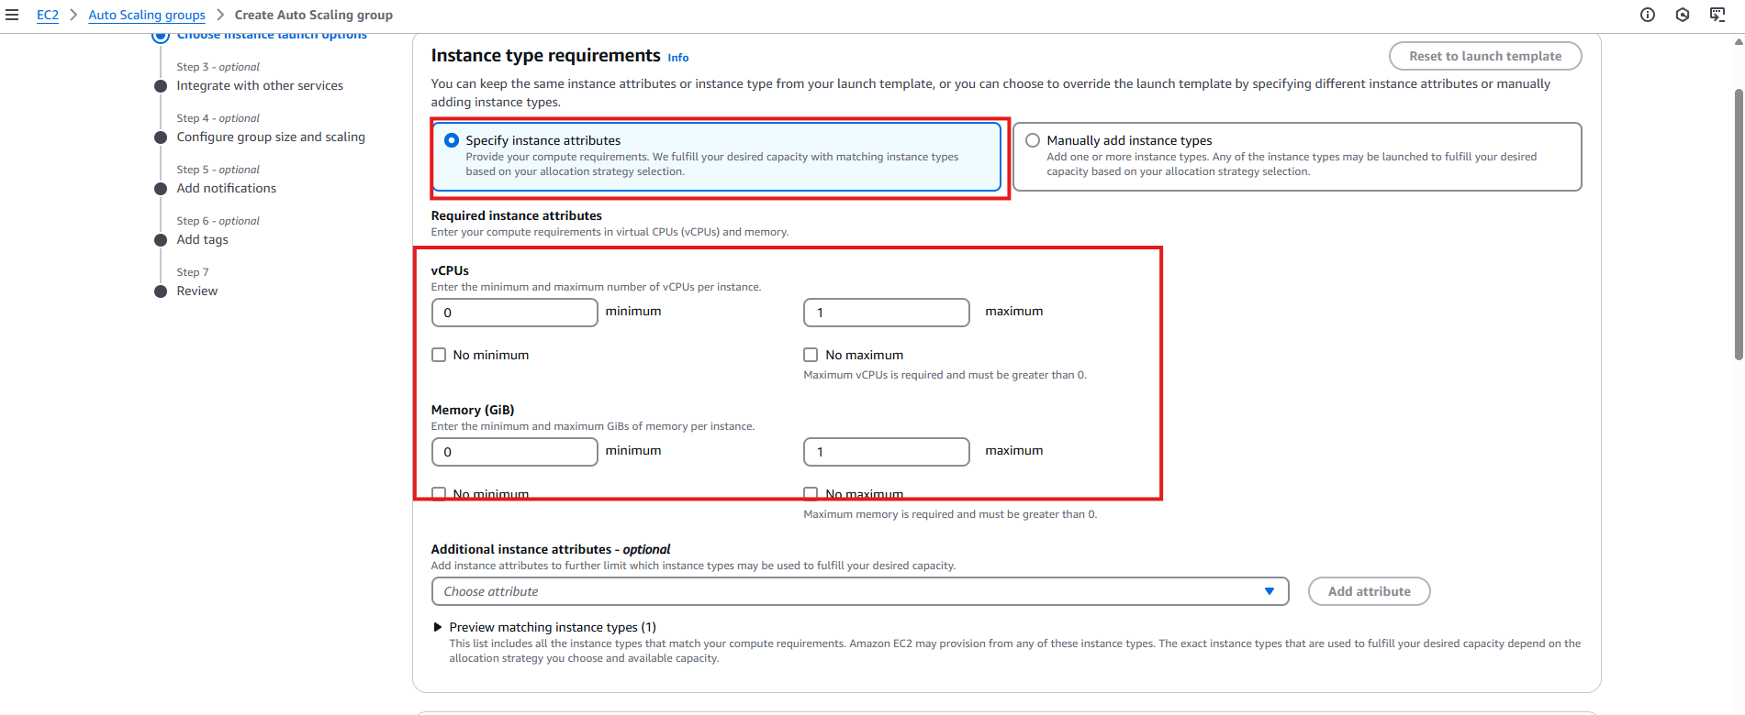

Choose all the availability zones.

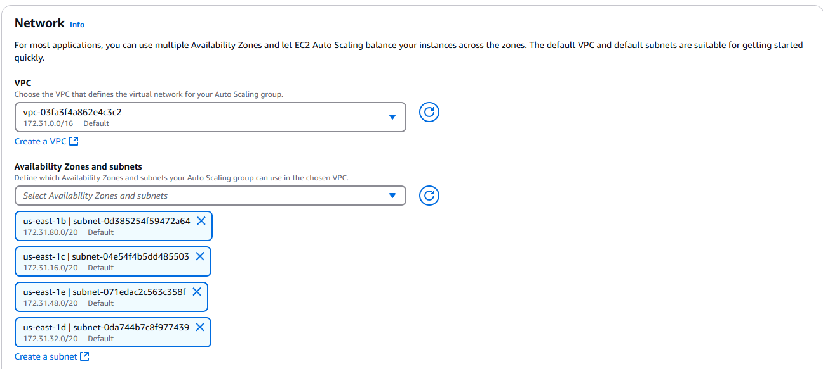

Configure and set no load balancing   
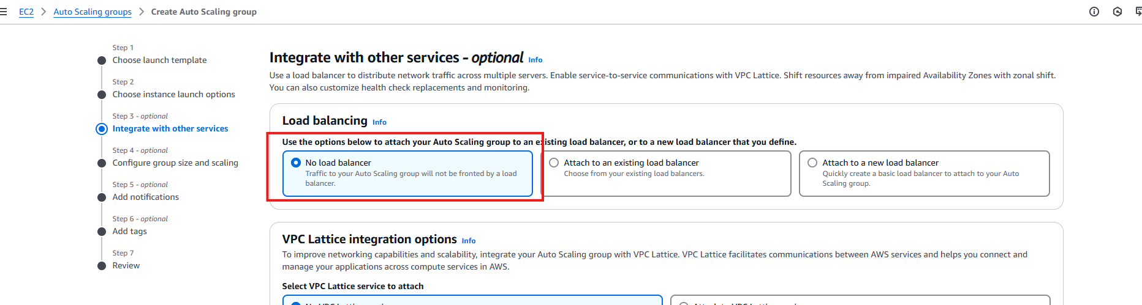

Select the configuration as below.  
 **Desired capacity** = **0**, **Minimum capacity** = **0** and, **Maximum capacity = 1** thenclick on  
**Next.**

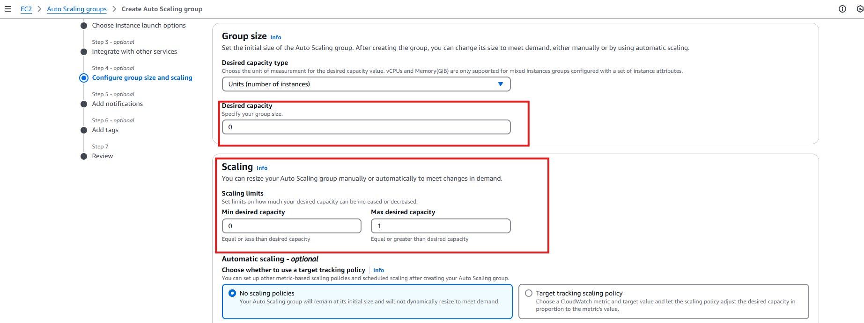

Keep the next steps to default and create the autoscaling group.  
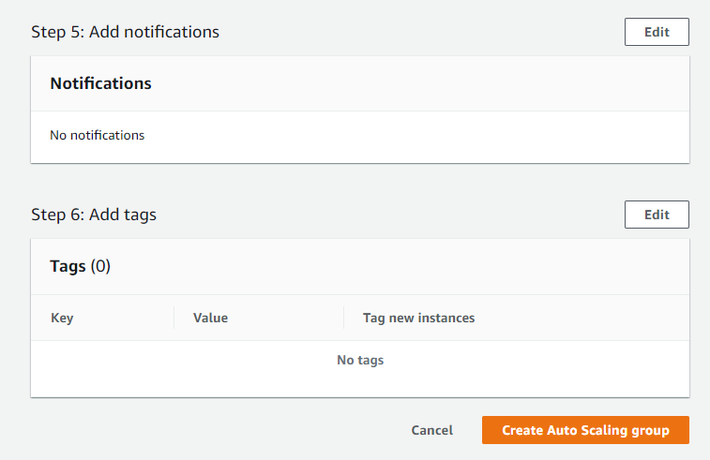

We have our autoscaling group created.

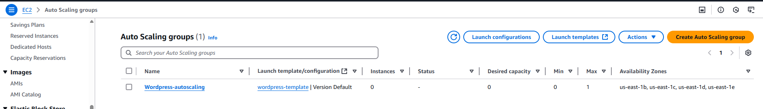

In autoscaling group dashboard click on Automatic scaling then scroll down to scheduled actions, then click on schedule action.  
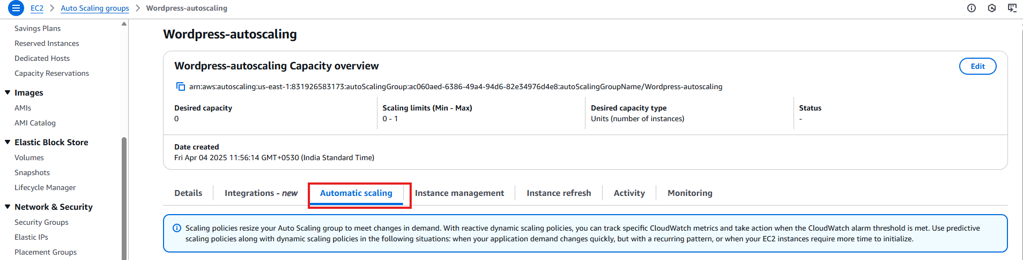

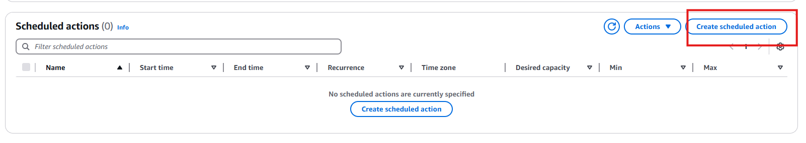

Create a scheduled action so that the instance should automatically trun on at 9:00 am IST and turnoff autoscaling at 6:00pm IST.

Enter a **Name**, for example, **SCALEUP_9AM**set the **Desired Capacity** as **one**, and then set the time when you want the job to run   
select the zone to ASIA/Kolkata set the date and time and click on create.  
this can changed to everyday if needed, so the instance will comeup everyday from 9:00am to 6:00pm IST  
  
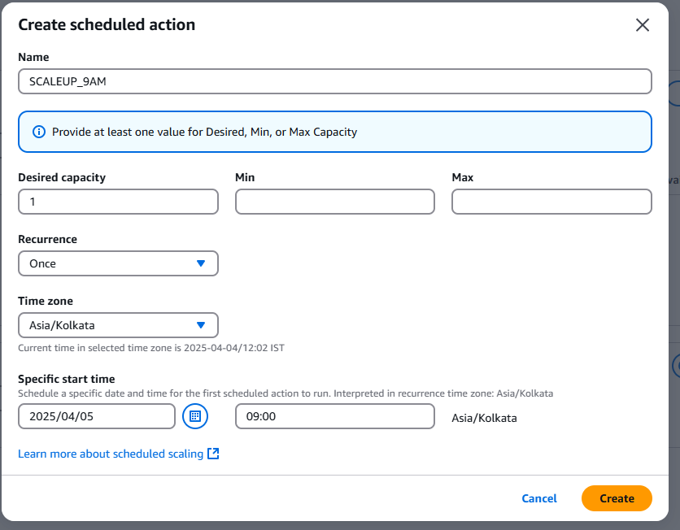

do the same for 6pm   
Enter a **Name**, for example, **SCALEDOWN_6PM**set the **Desired Capacity** as **zero**, and then set the time when you want the job to run   
select the zone to ASIA/Kolkata set the date and time and click on create.

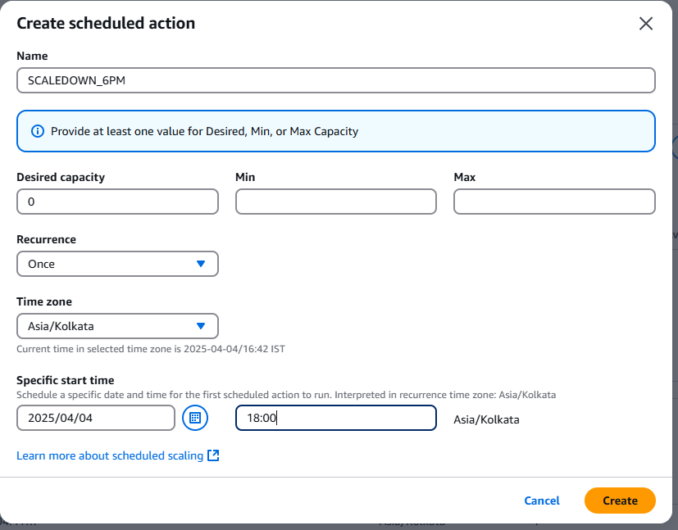

We have our scheduled action created  
  
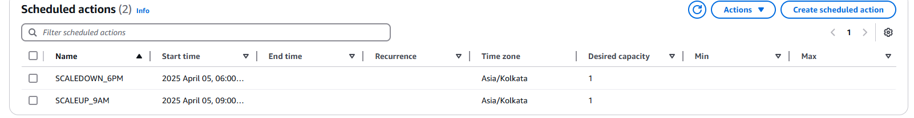

Done we are good with the autoscaling.

The autoscaling group will schedule this at the mentioned time and we will be able to operate and use the wordpress instance configured with EC2, RDS and S3 bucket.

Once activated this can view from the public ip from EC2 instances dashboard.  
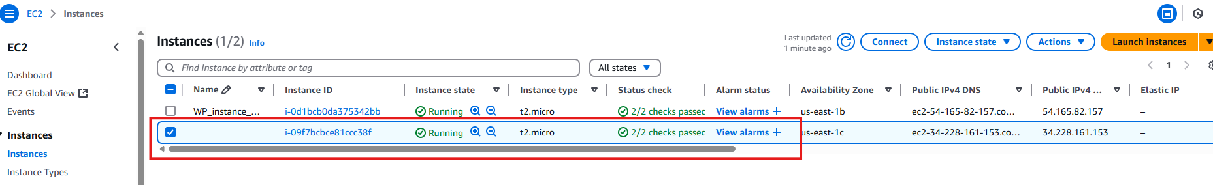

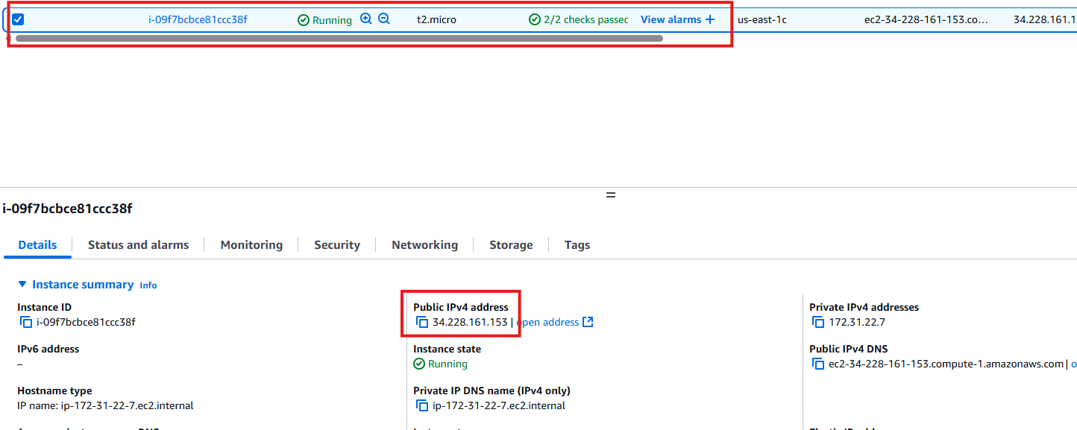

Congrats!! Your wordpress blog is hosted on time and ready.

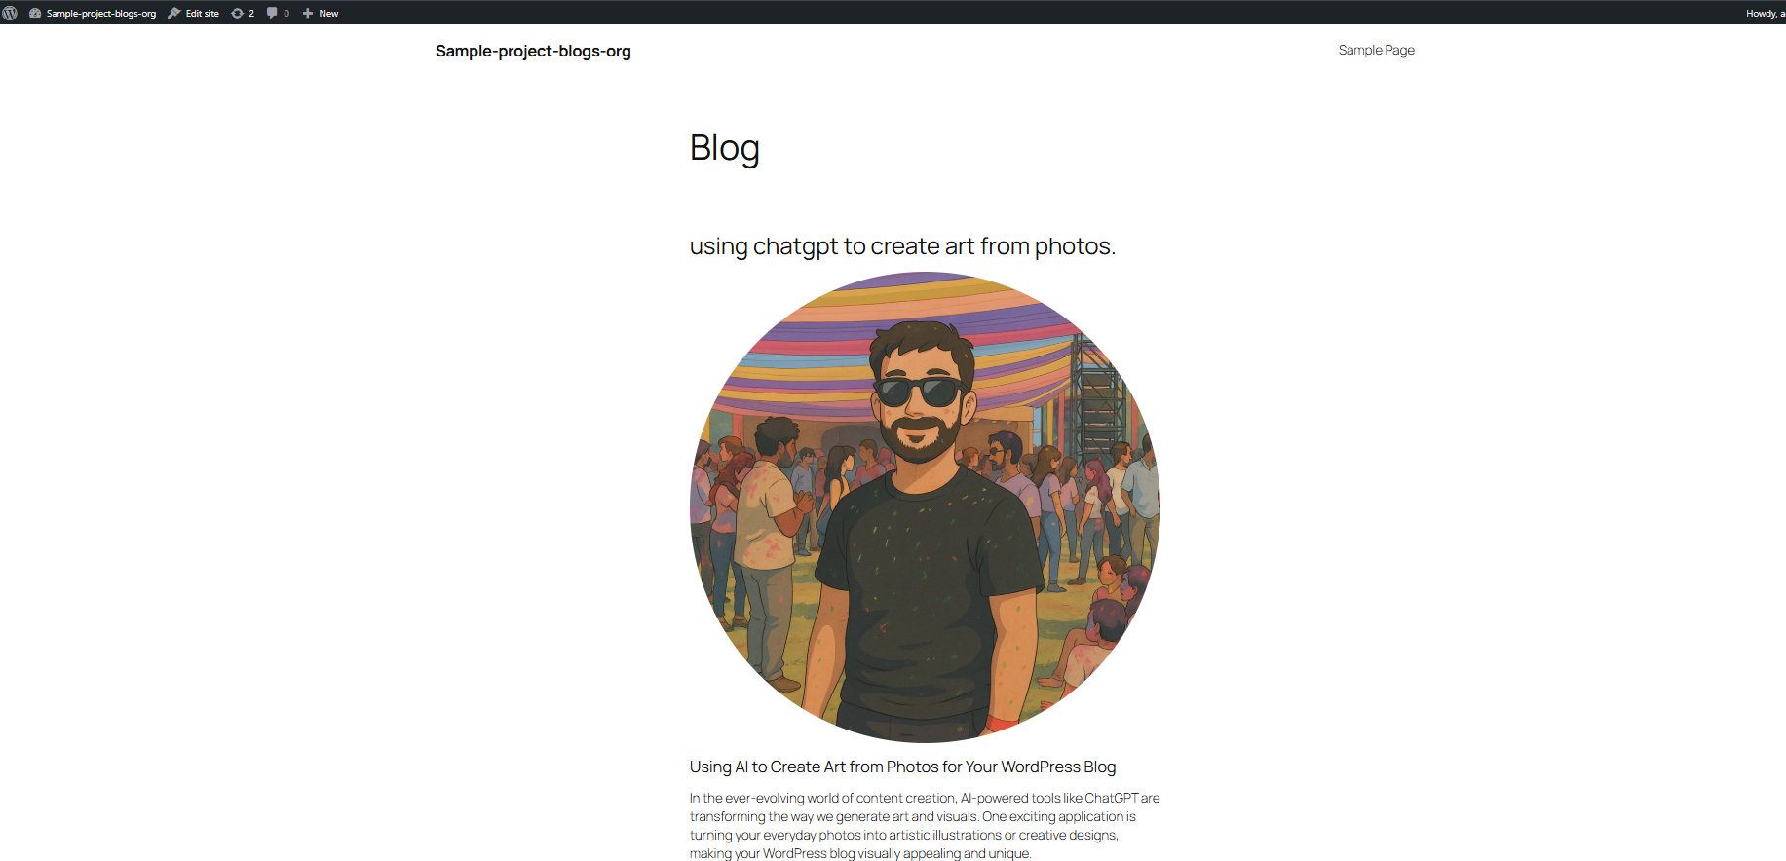

Now Monitoring the hosted wordpress instance.  
  
Open Route53 from AWS console to moniter the health of the instance.  
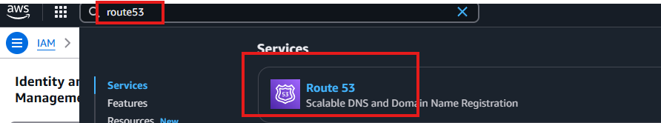

Click on configure health checks.  
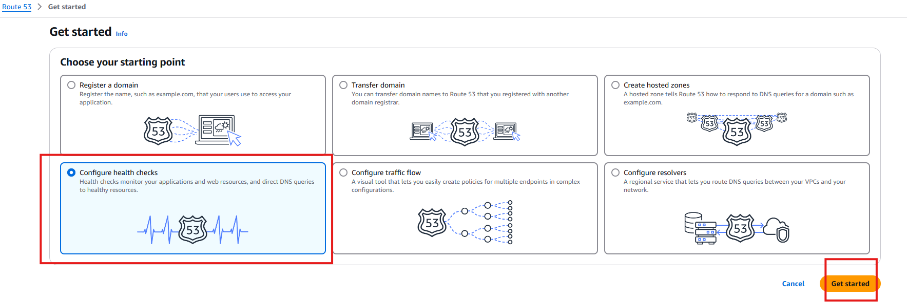

Create a name for the helath check configuration, menion the IP address from the EC2 instance dashboard. And create Health check  
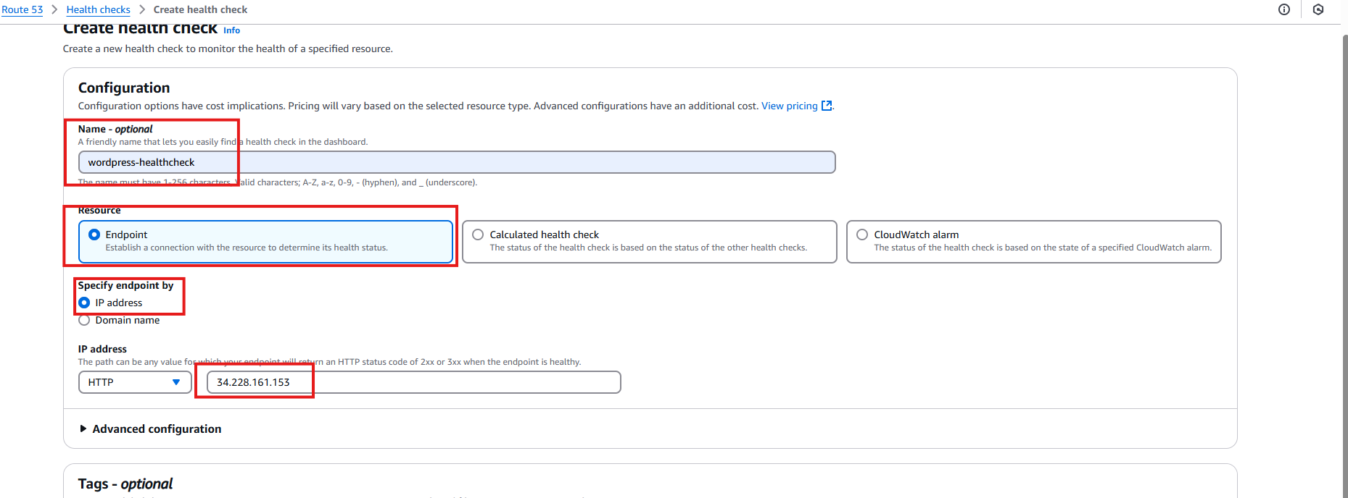

By this we will be able to view the logs and see which availability regions is the host failing.

Example.  
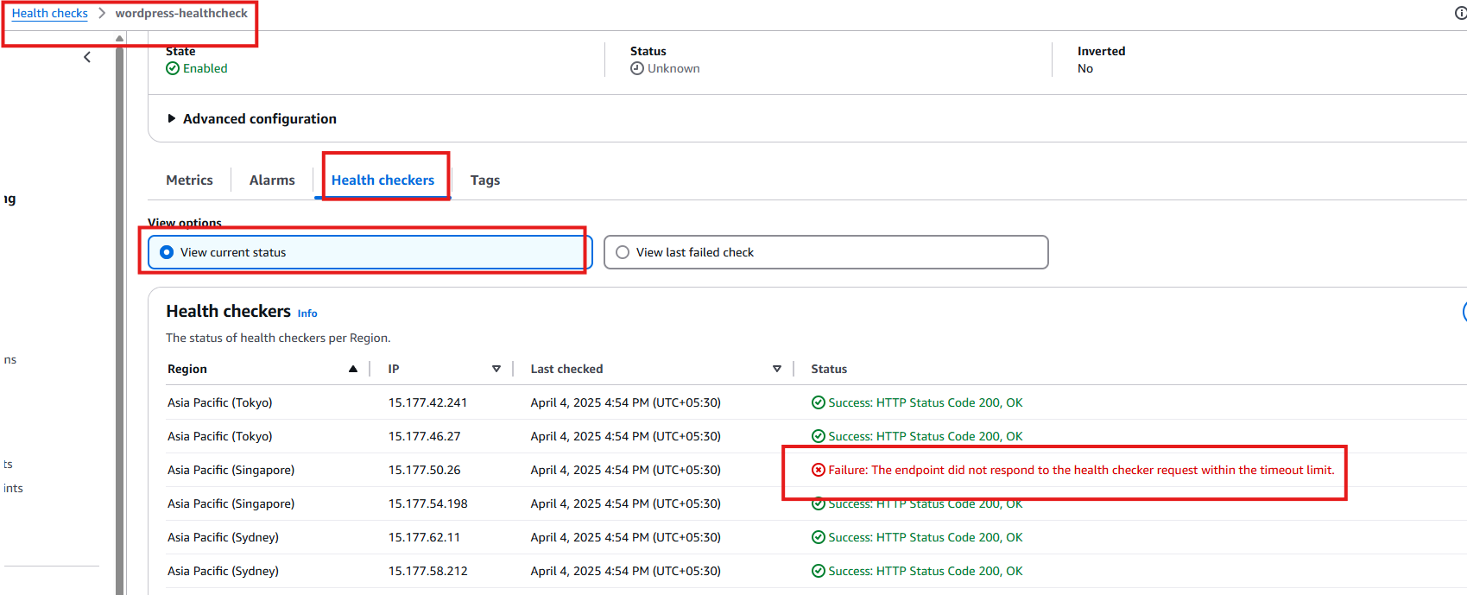

We will be able to see if the instance is healthy or not.  
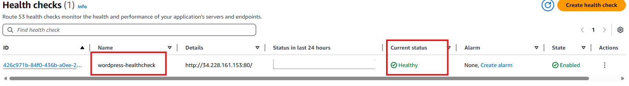

This way we can set up wordpress instance with EC2, RDS,S3 and autoscaling it accordingly and monitor it using Route53.

We can watch all the metrics for EC2 , Autoscaling, RDS instances while they were running.  
these settings were all made while configuring RDS,EC2 and Autoscale configuration.  
few of them even have default configuration set with cloudwatch.

Open Cloudwatch on AWS console.  
go to dashboard-> automatic dashboard.  
  
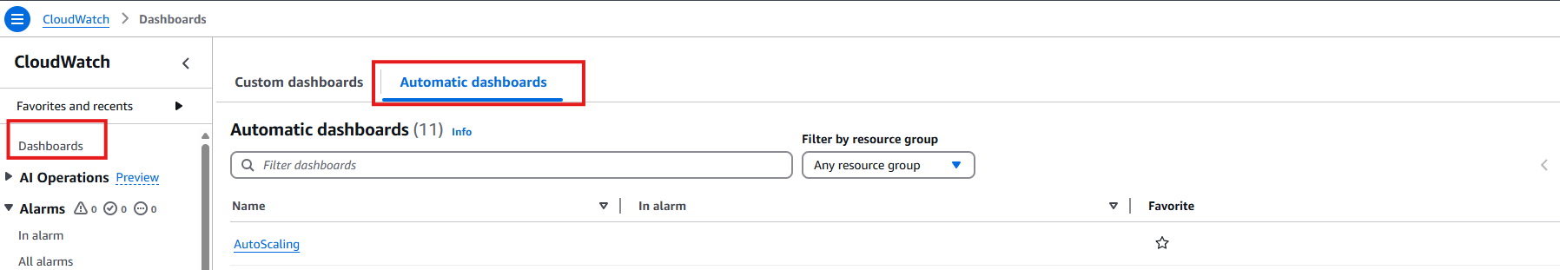

You can open the below dashboard to moniter you project metrics as these were enabled during setting up instances.  
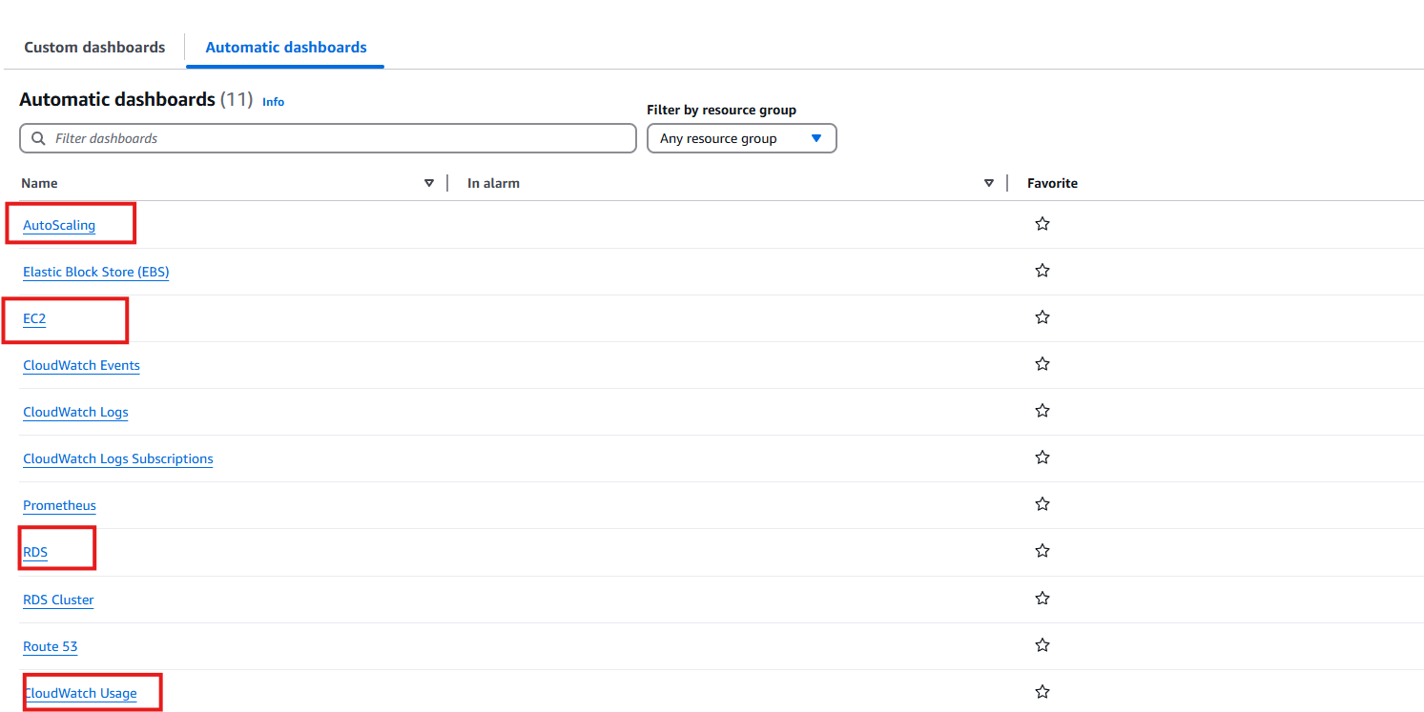

AUTOSCALING:  
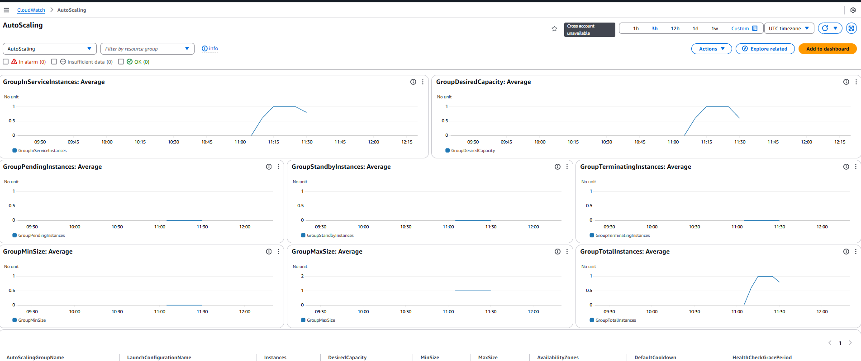

EC2:  
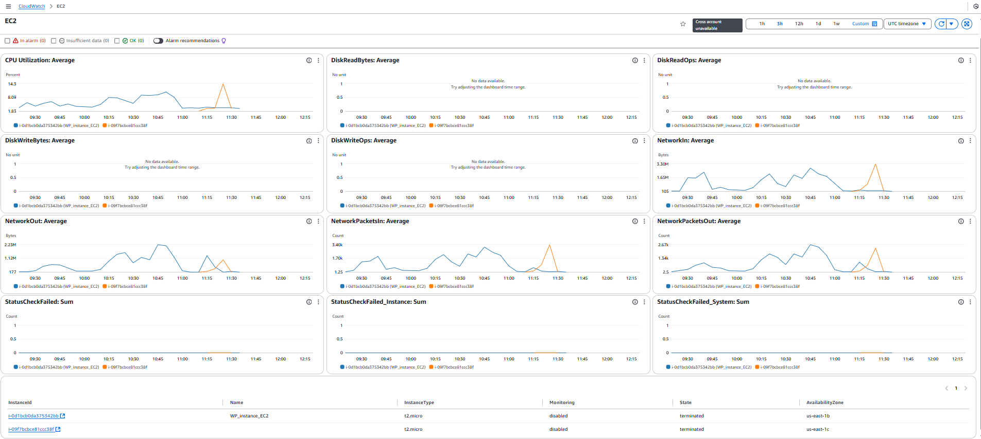

RDS:  
